20CYS315

**Cyber Forensics**

**V. JAYARAJ**

**21026**

**EX-1: Autopsy**

**Aim:** Analyze Image files using Autopsy

**Output:**

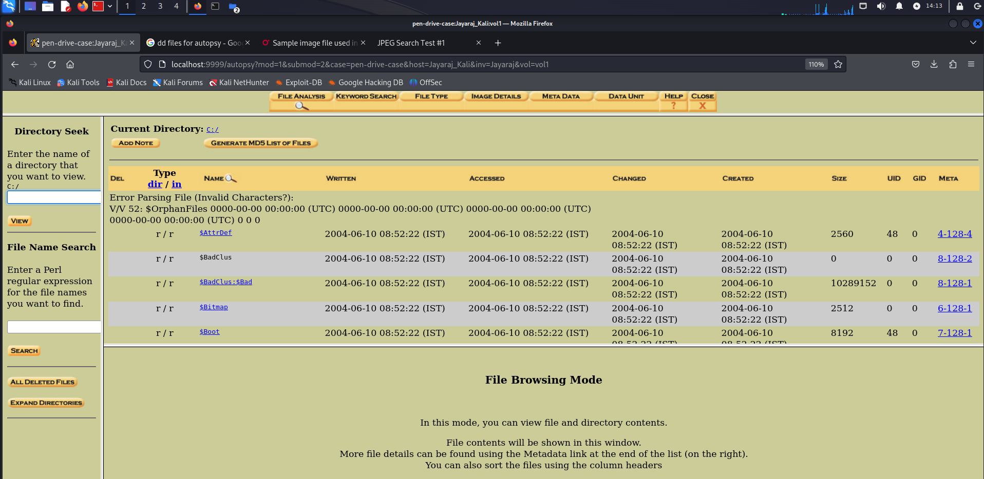

A new case file of “dd file” obtained from pen drive (downloaded from internet).

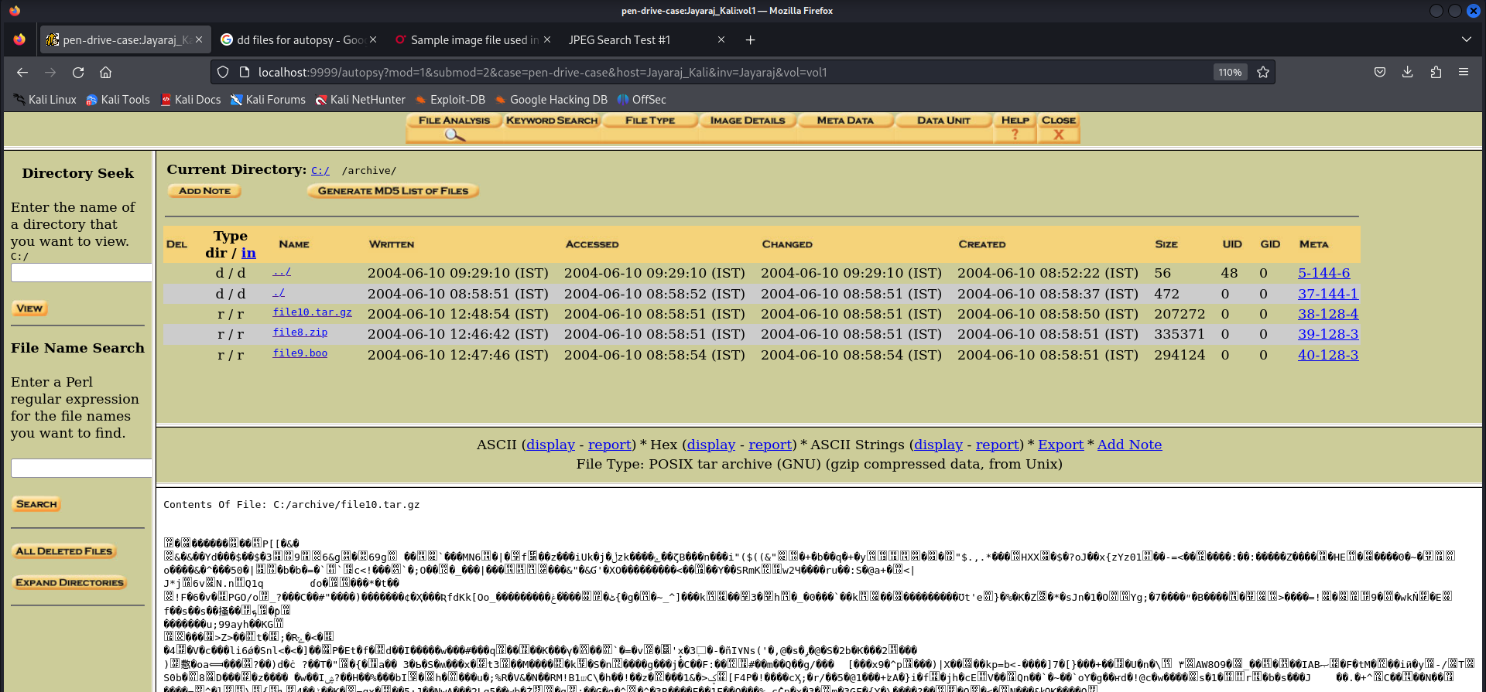

Some of the contents of the recoverable file which is partially erased.

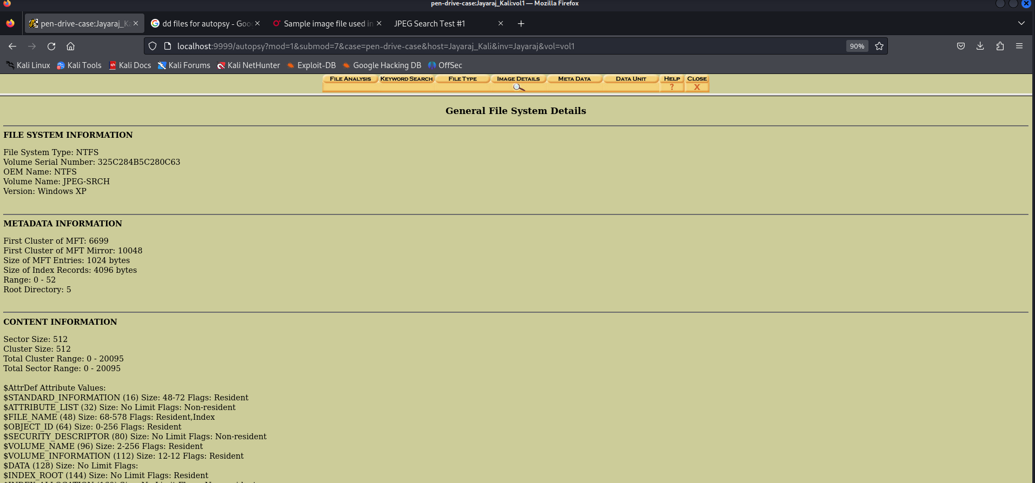

DD file meta information with hash value for integrity checking.

|  |  |
| --- | --- |
|  |  |

**EX-2: Disk analysis and Autopsy (TryHackMe)**

**Aim:**

Perform a case analysis on tryhackme using autopsy

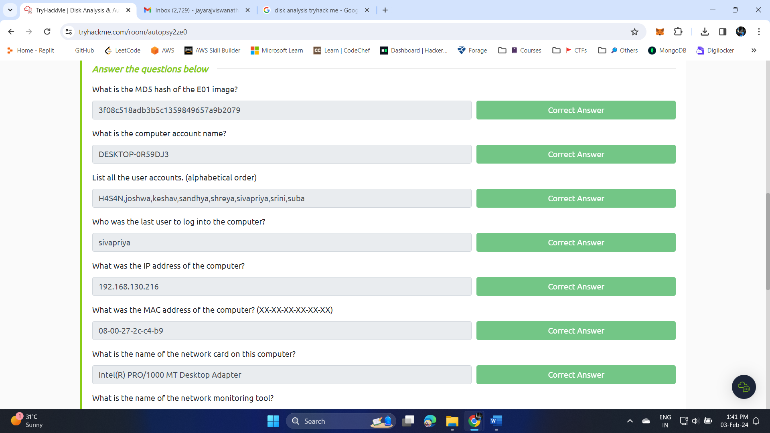

1. What is the MD5 hash of the E01 image? - 3f08c518adb3b5c1359849657a9b2079

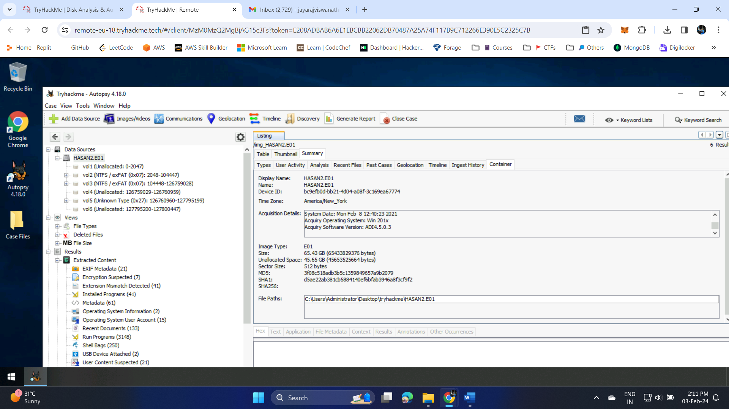

1. What is the computer account name? - DESKTOP-0R59DJ3

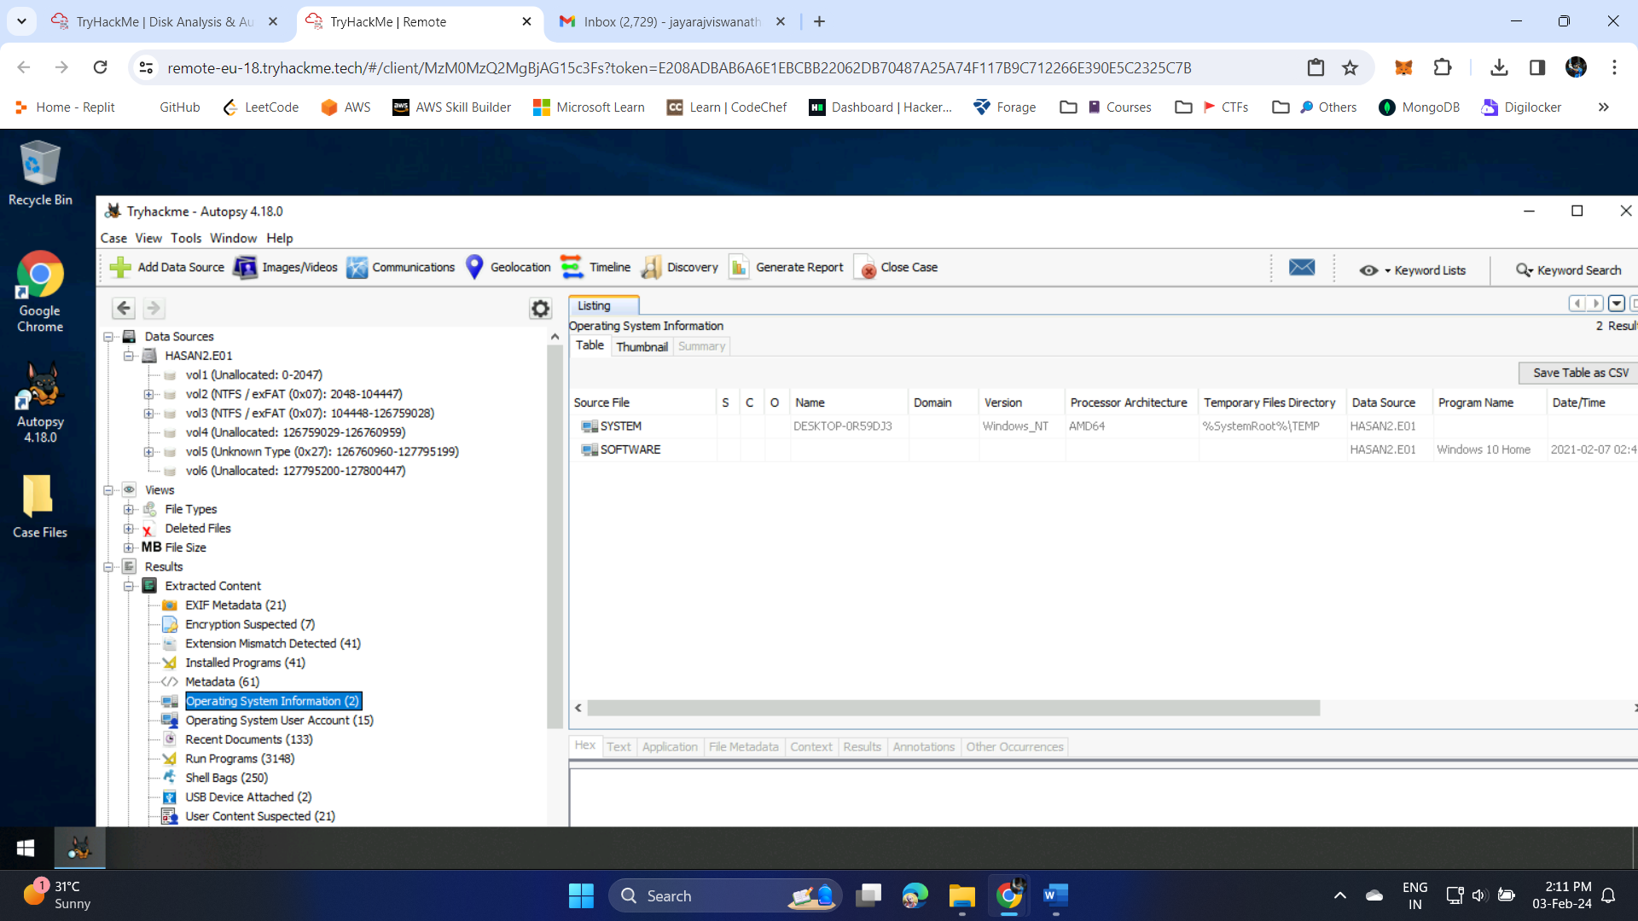

1. List all the user accounts. (alphabetical order) -H4S4N, joshwa, keshav, sandhya, shreya, sivapriya, srini, suba

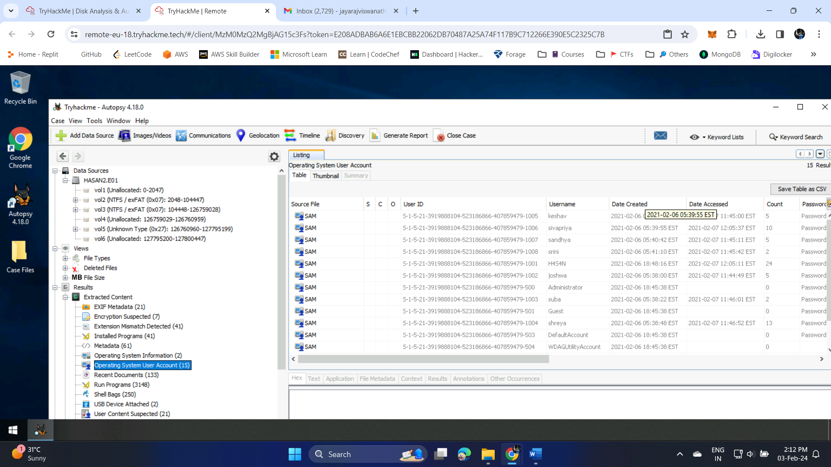

1. Who was the last user to log into the computer? – Sivapriya

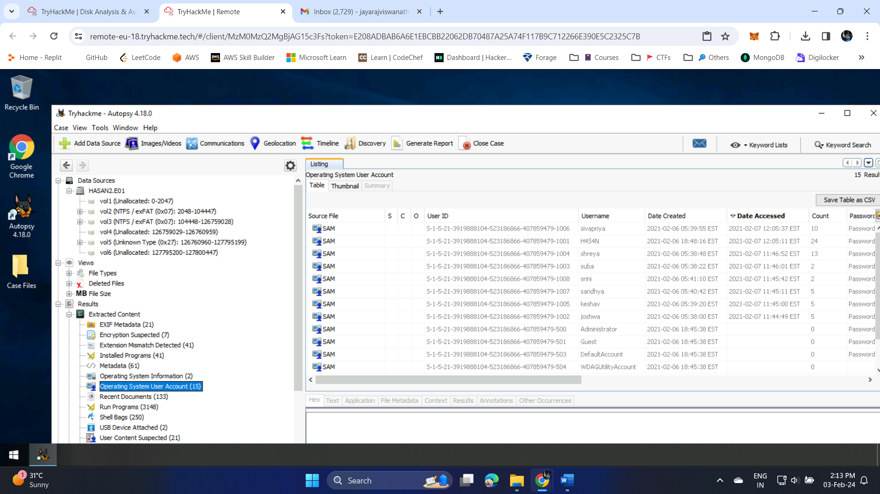

1. What was the IP address of the computer? - 192.168.130.216

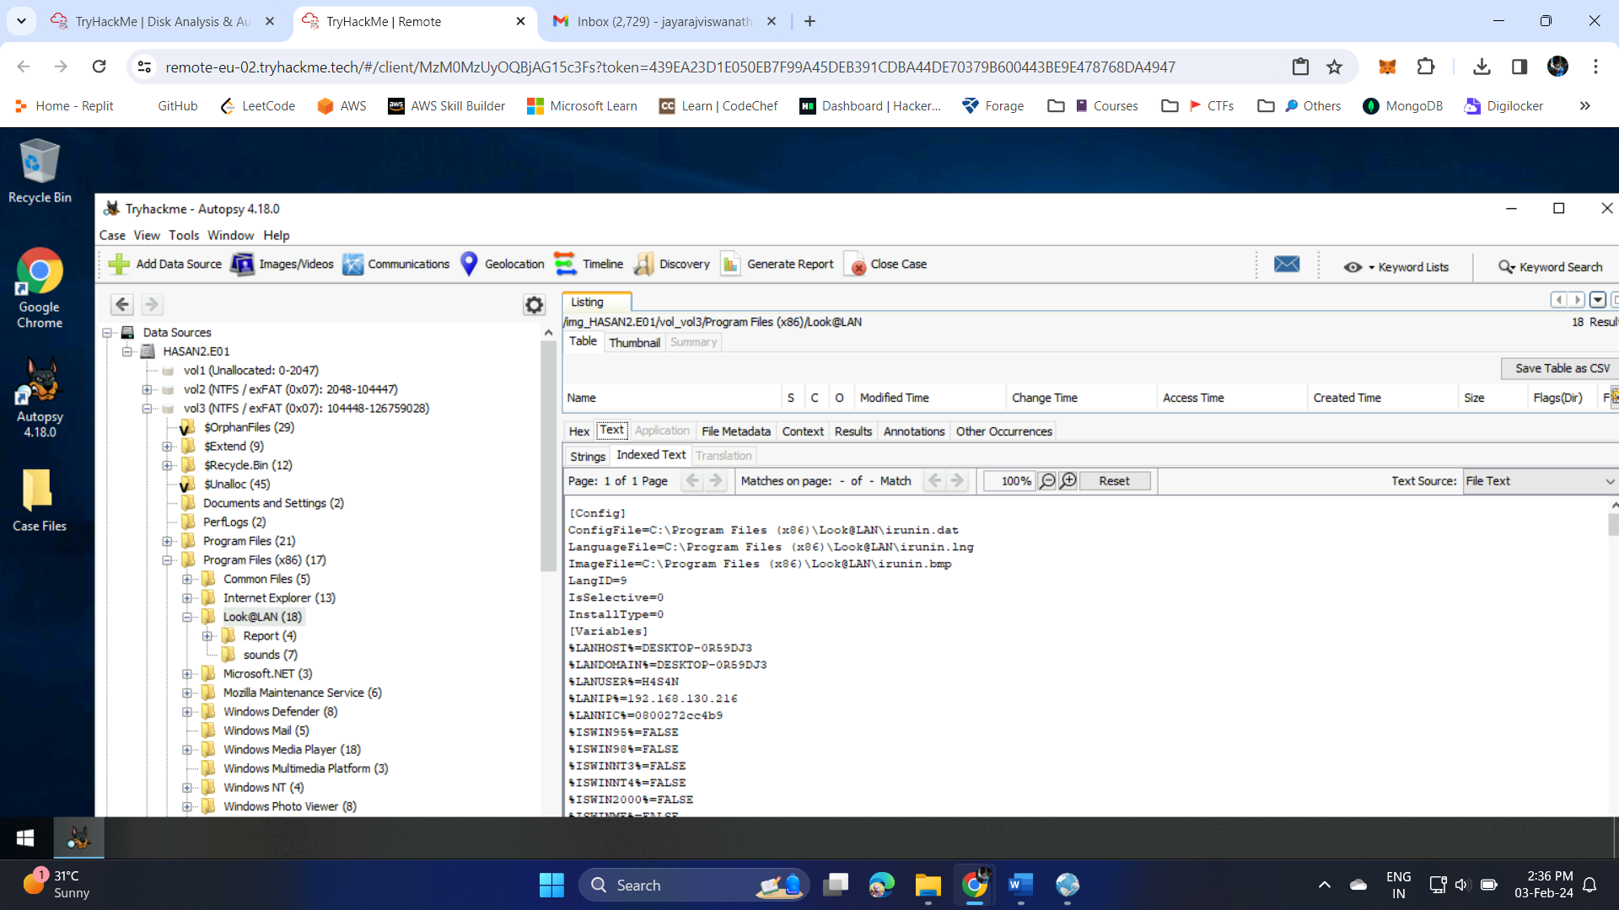

1. What was the MAC address of the computer? (XX-XX-XX-XX-XX-XX) - 08-00-27-2c-c4-b9



1. What is the name of the network card on this computer? - Intel(R) PRO/1000 MT Desktop Adapter

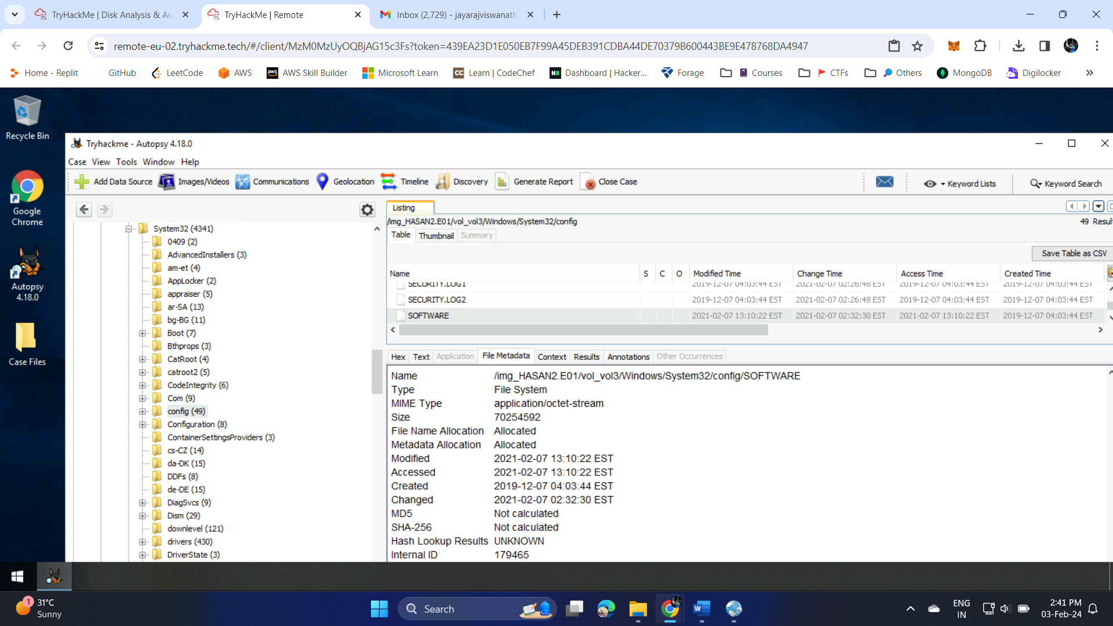

1. What is the name of the network monitoring tool? - Look@LAN



1. A user bookmarked a Google Maps location. What are the coordinates of the location? - 12°52'23.0"N 80°13'25.0"E

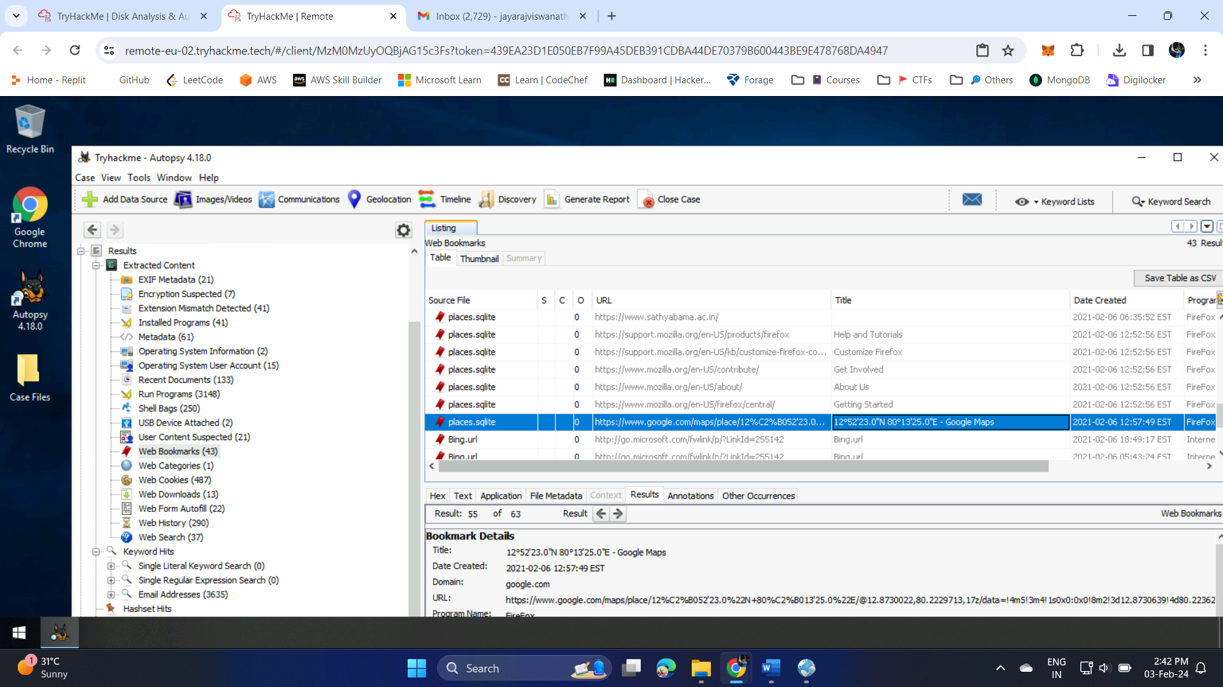

1. A user has his full name printed on his desktop wallpaper. What is the user's full name? - Anto Joshwa

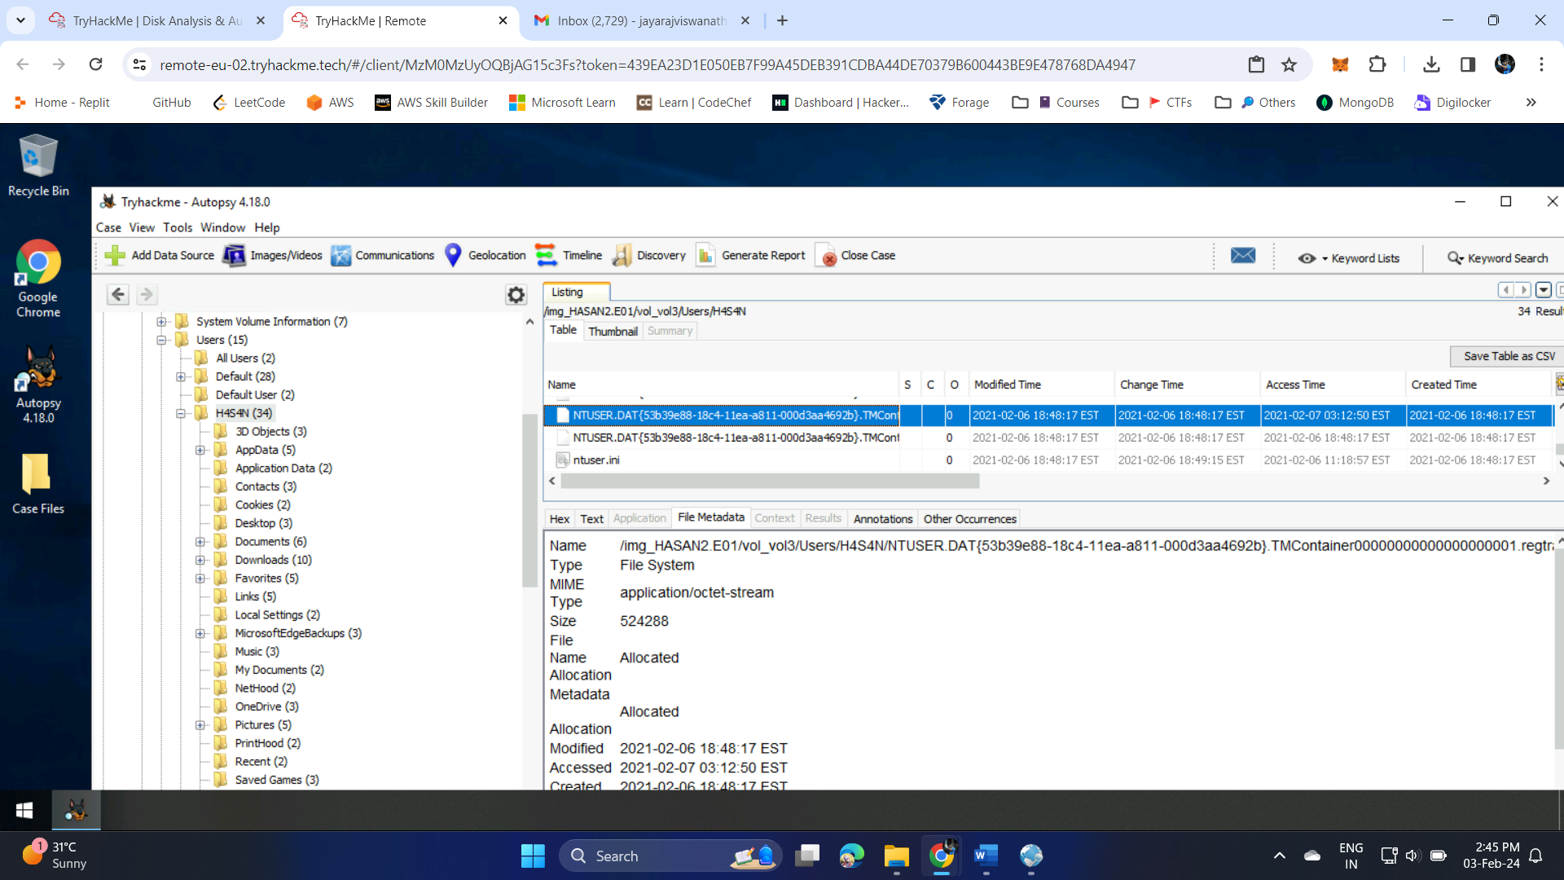

1. A user had a file on her desktop. It had a flag but she changed the flag using PowerShell. What was the first flag? - flag{HarleyQuinnForQueen}

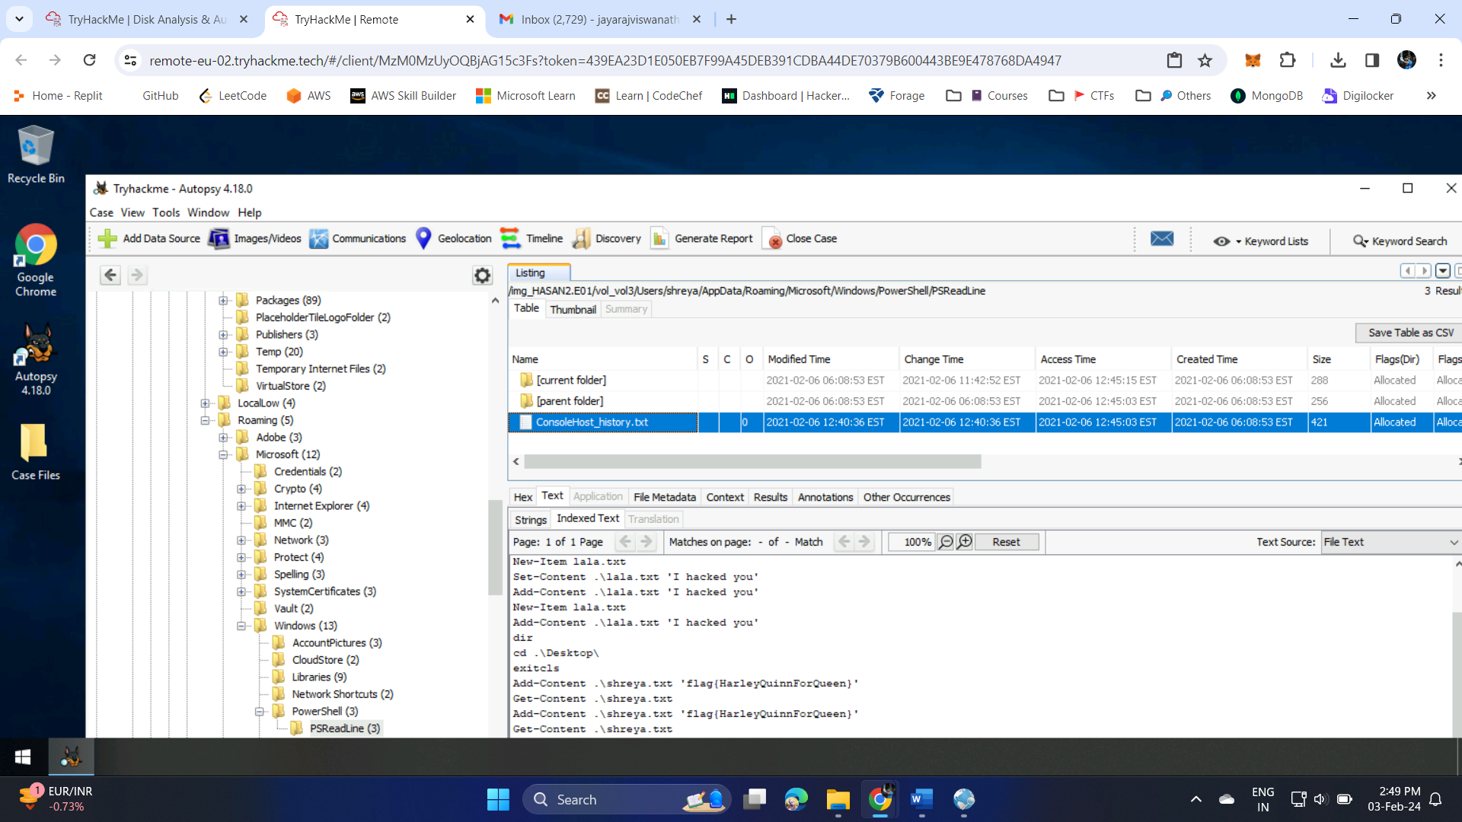

1. The same user found an exploit to escalate privileges on the computer. What was the message to the device owner? - flag{I-hacked-you}

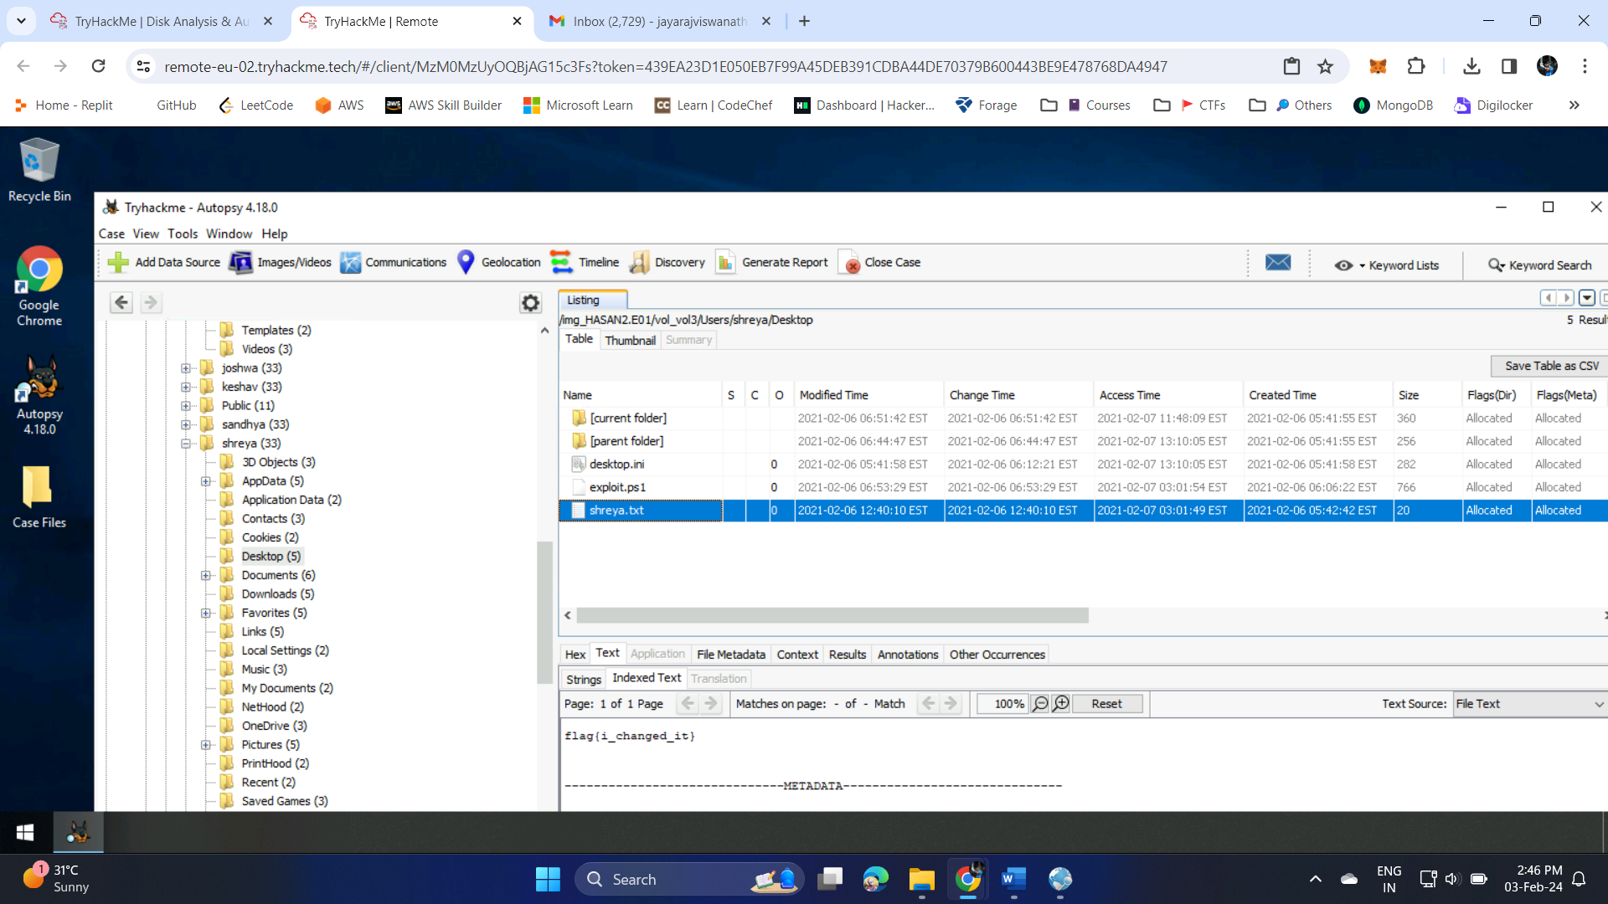

1. 2 hack tools focused on passwords were found in the system. What are the names of these tools? (alphabetical order) - Lazagne,Mimikatz

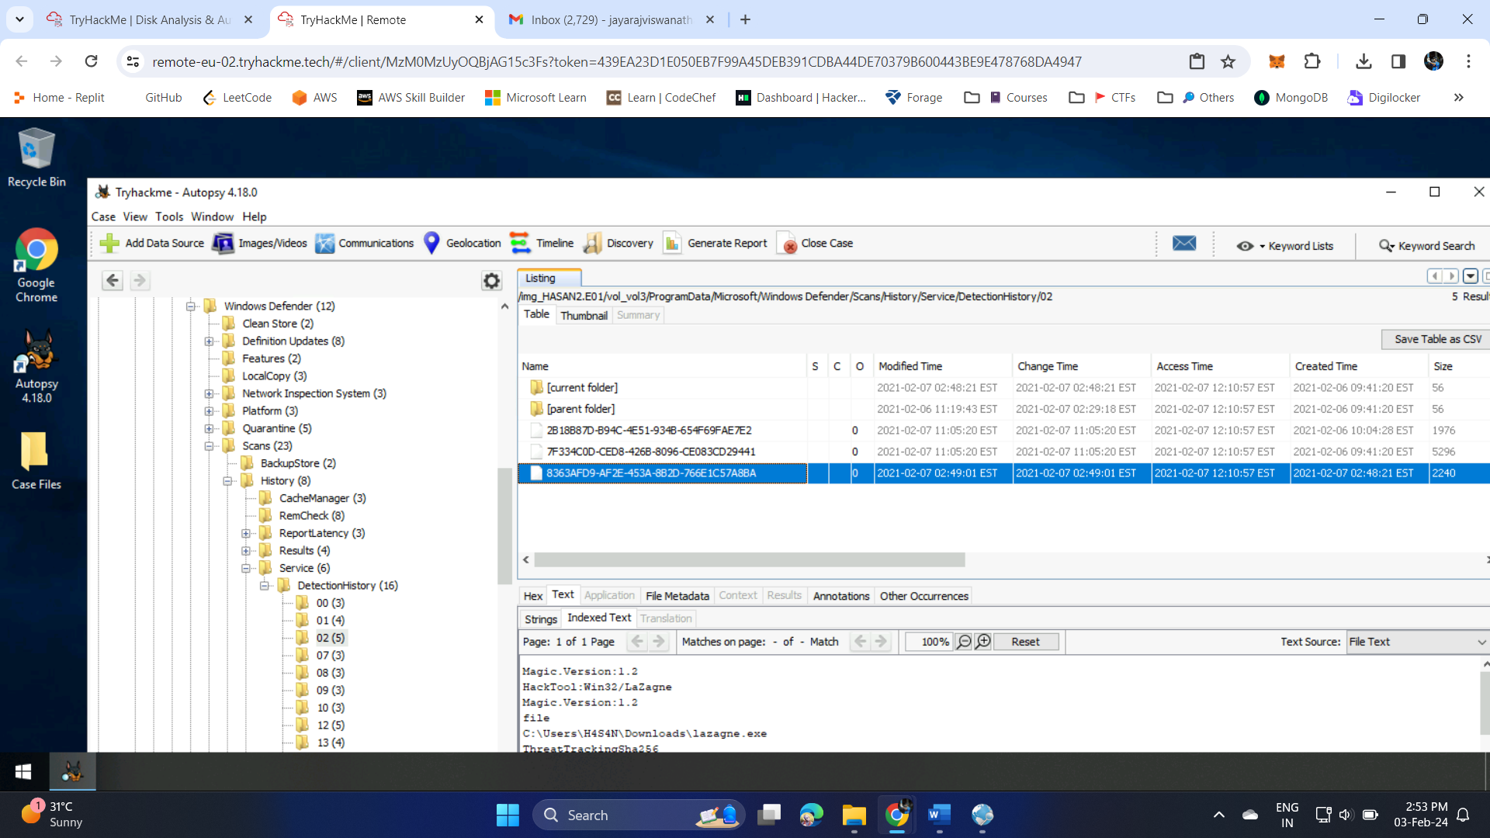

1. There is a YARA file on the computer. Inspect the file. What is the name of the author? - Benjamin DELPY (gentilkiwi)

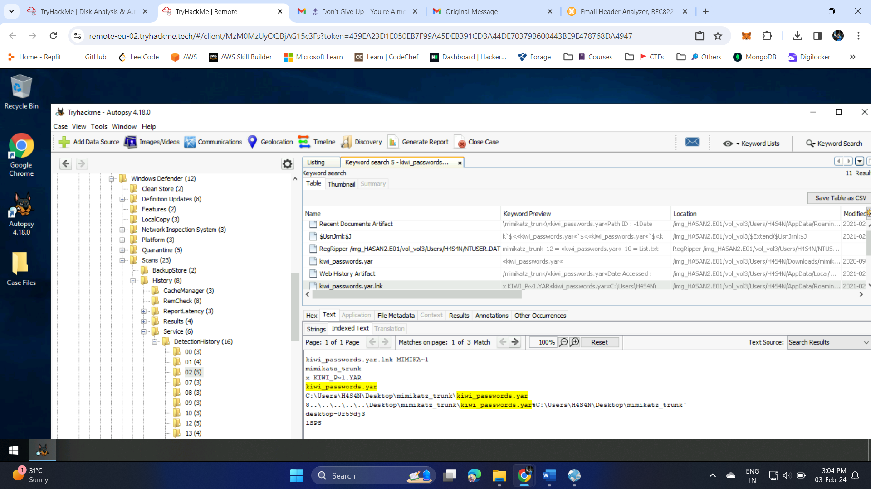

1. One of the users wanted to exploit a domain controller with an MS-NRPC based exploit. What is the filename of the archive that you found? (include the spaces in your answer) - 2.2.0 20200918 Zerologon encrypted.zip

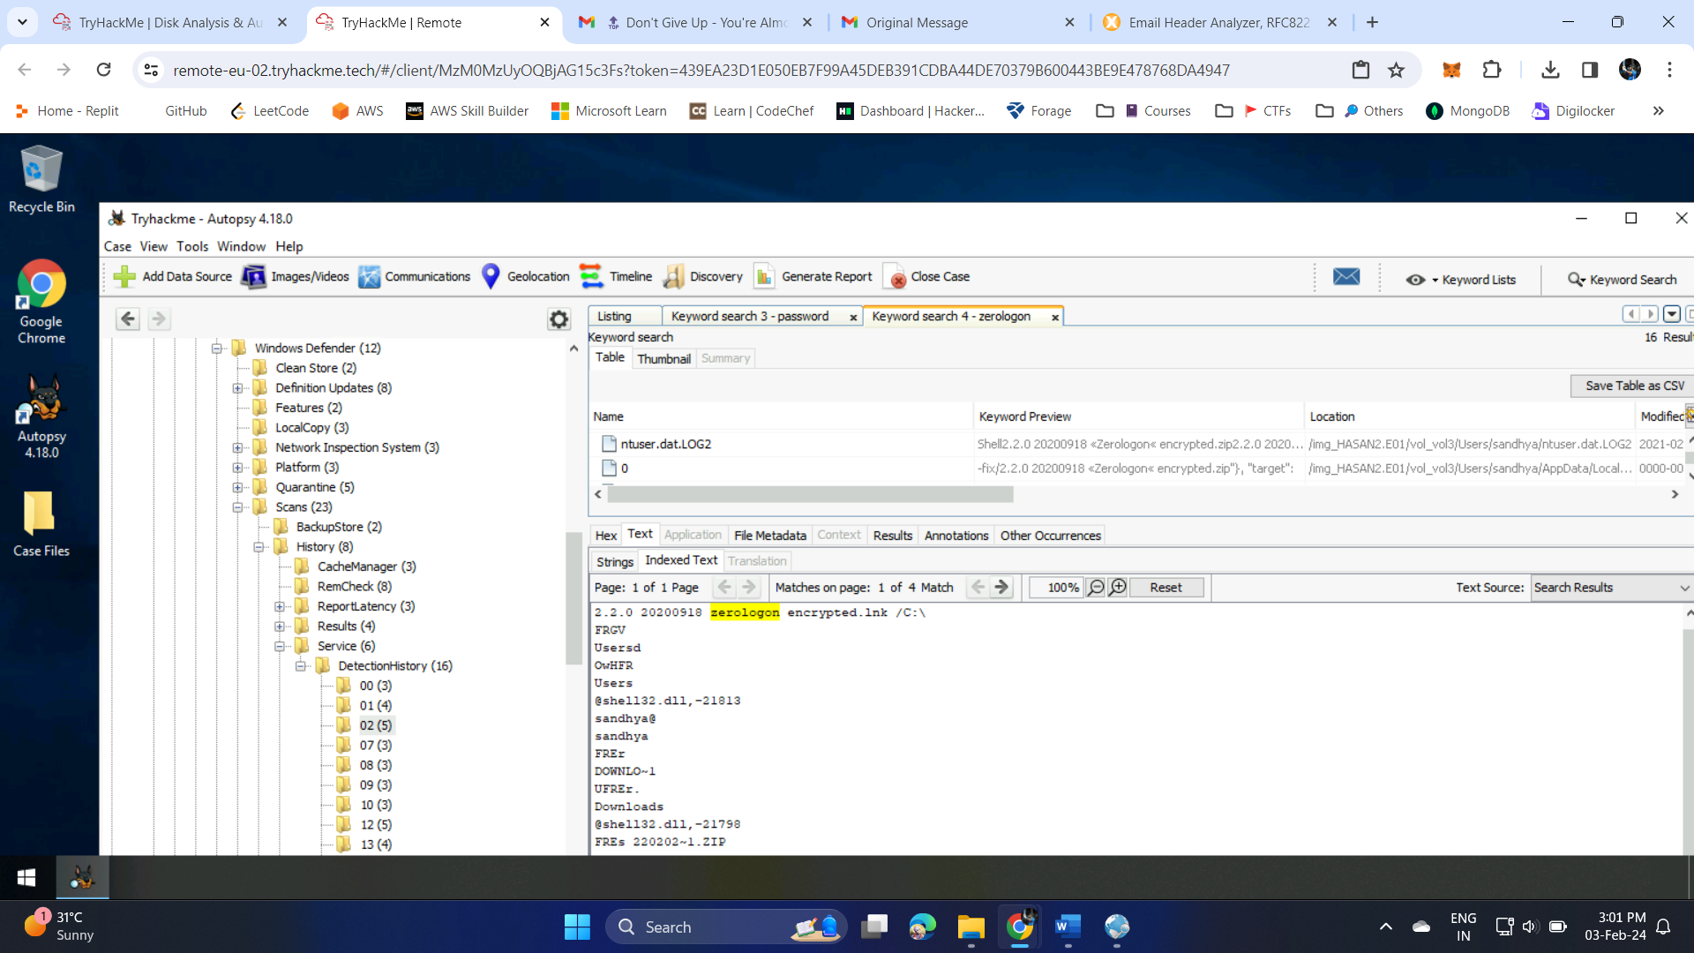

**EX-3-Email Forensics**

**Aim:** Extract the original content from and email and check the headers.

1. Load the original content of a mail in a online tool for header analysis.

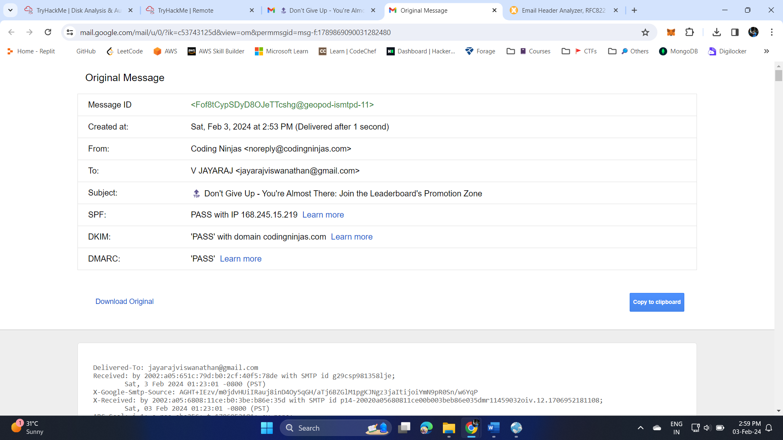

1. Header Anaysis

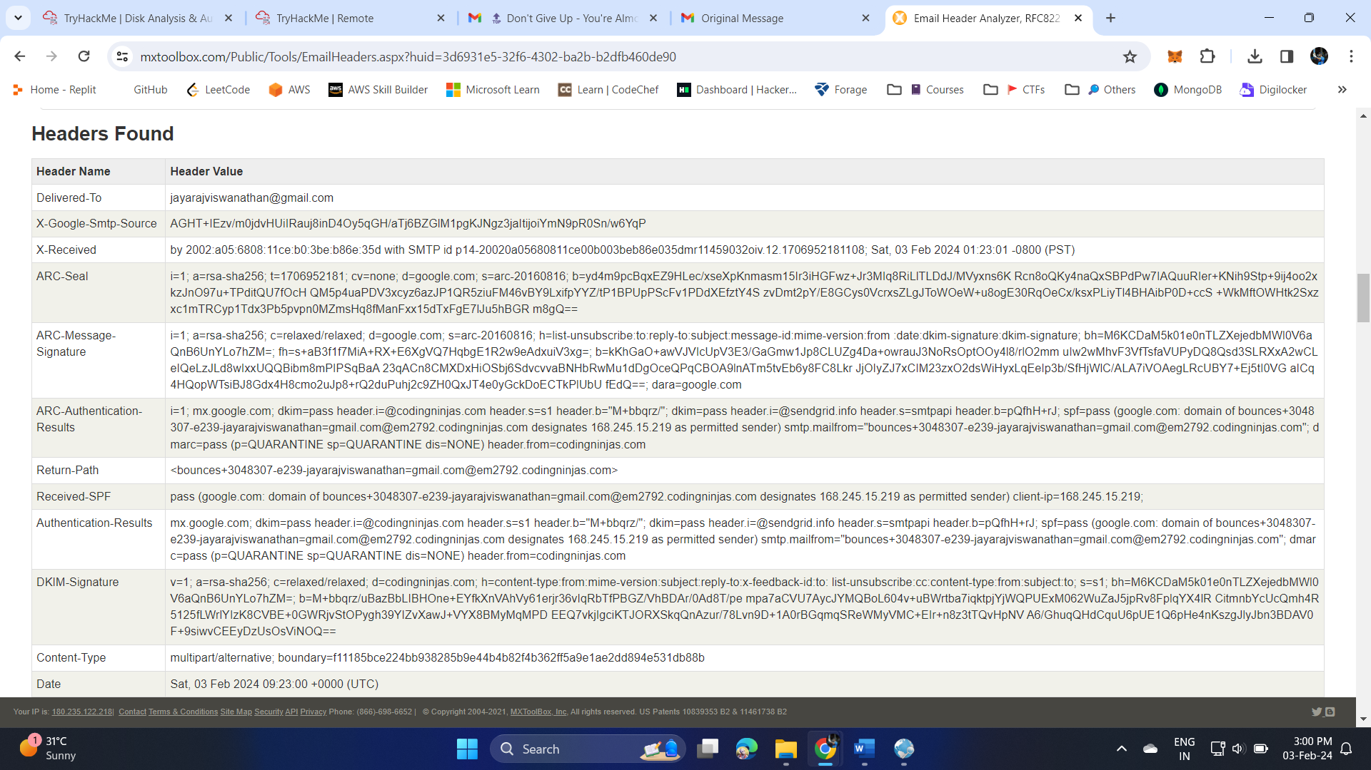

1. Tool- google header analyser

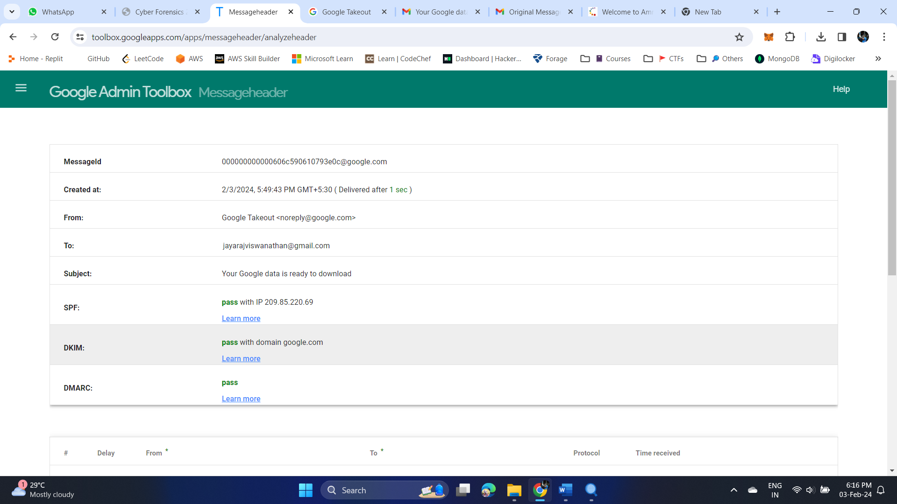

|  |  |
| --- | --- |
|  |  |

**EX-4-Email Forensics using Google Takeout**

**Aim:** Analyze mails obtained form google takeout

1. Backup files from google takeout and perform forensics

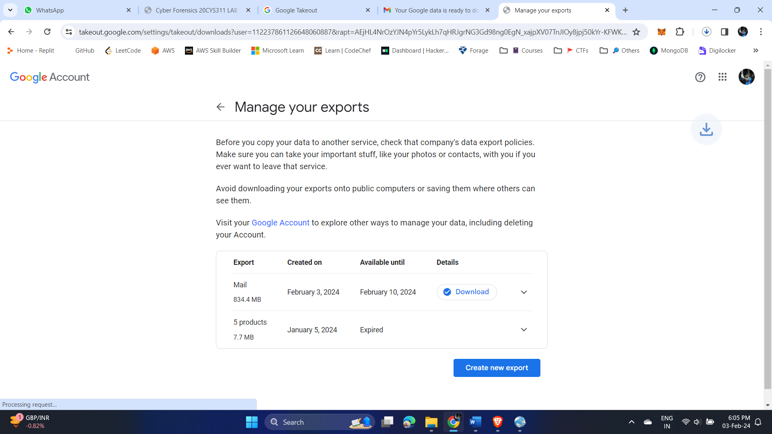

1. Open the downloaded zip file using 4n6 viewer tool.

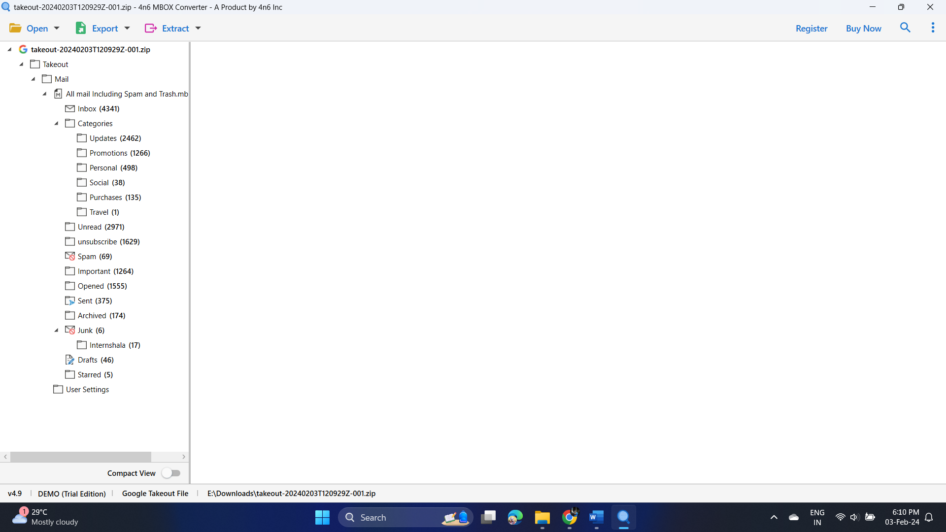

1. The mails can be viewed in various forms – Message Header

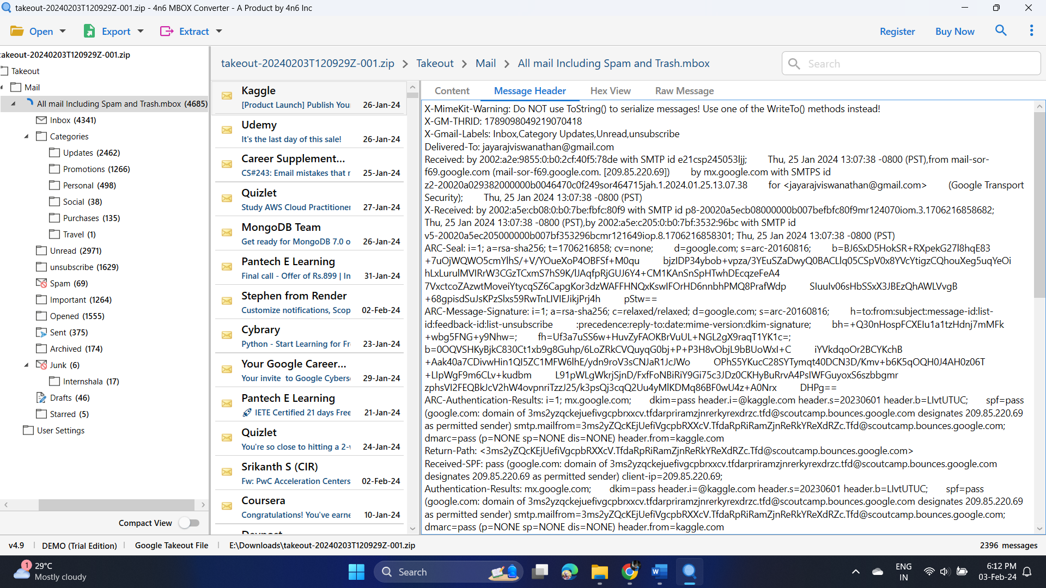

1. Hex View

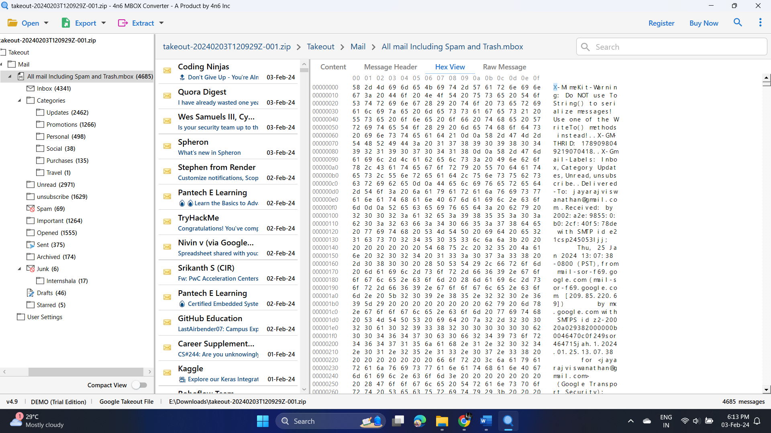

1. Raw message

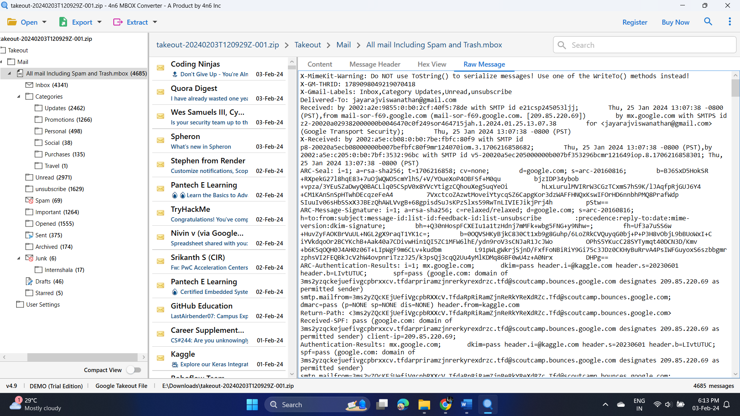

**EX-5: E-mail Forensics (TryHackMe)**

**Aim:**

Analyze emails in TryHackMe

**Output:**

1. What phrase does the gibberish sender email start with? – noreply

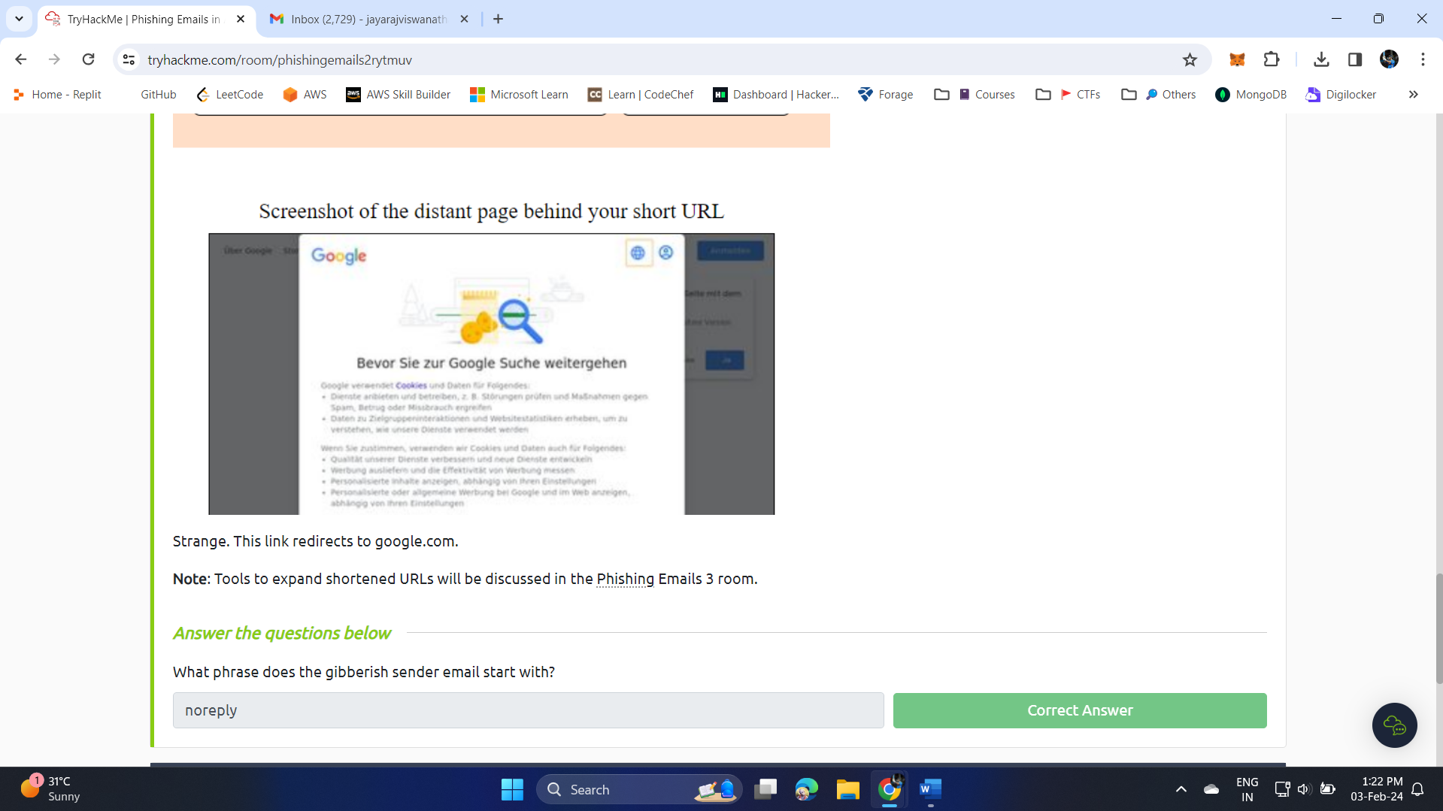

1. What is the root domain for each URL? Defang the URL. - devret[.]xyz

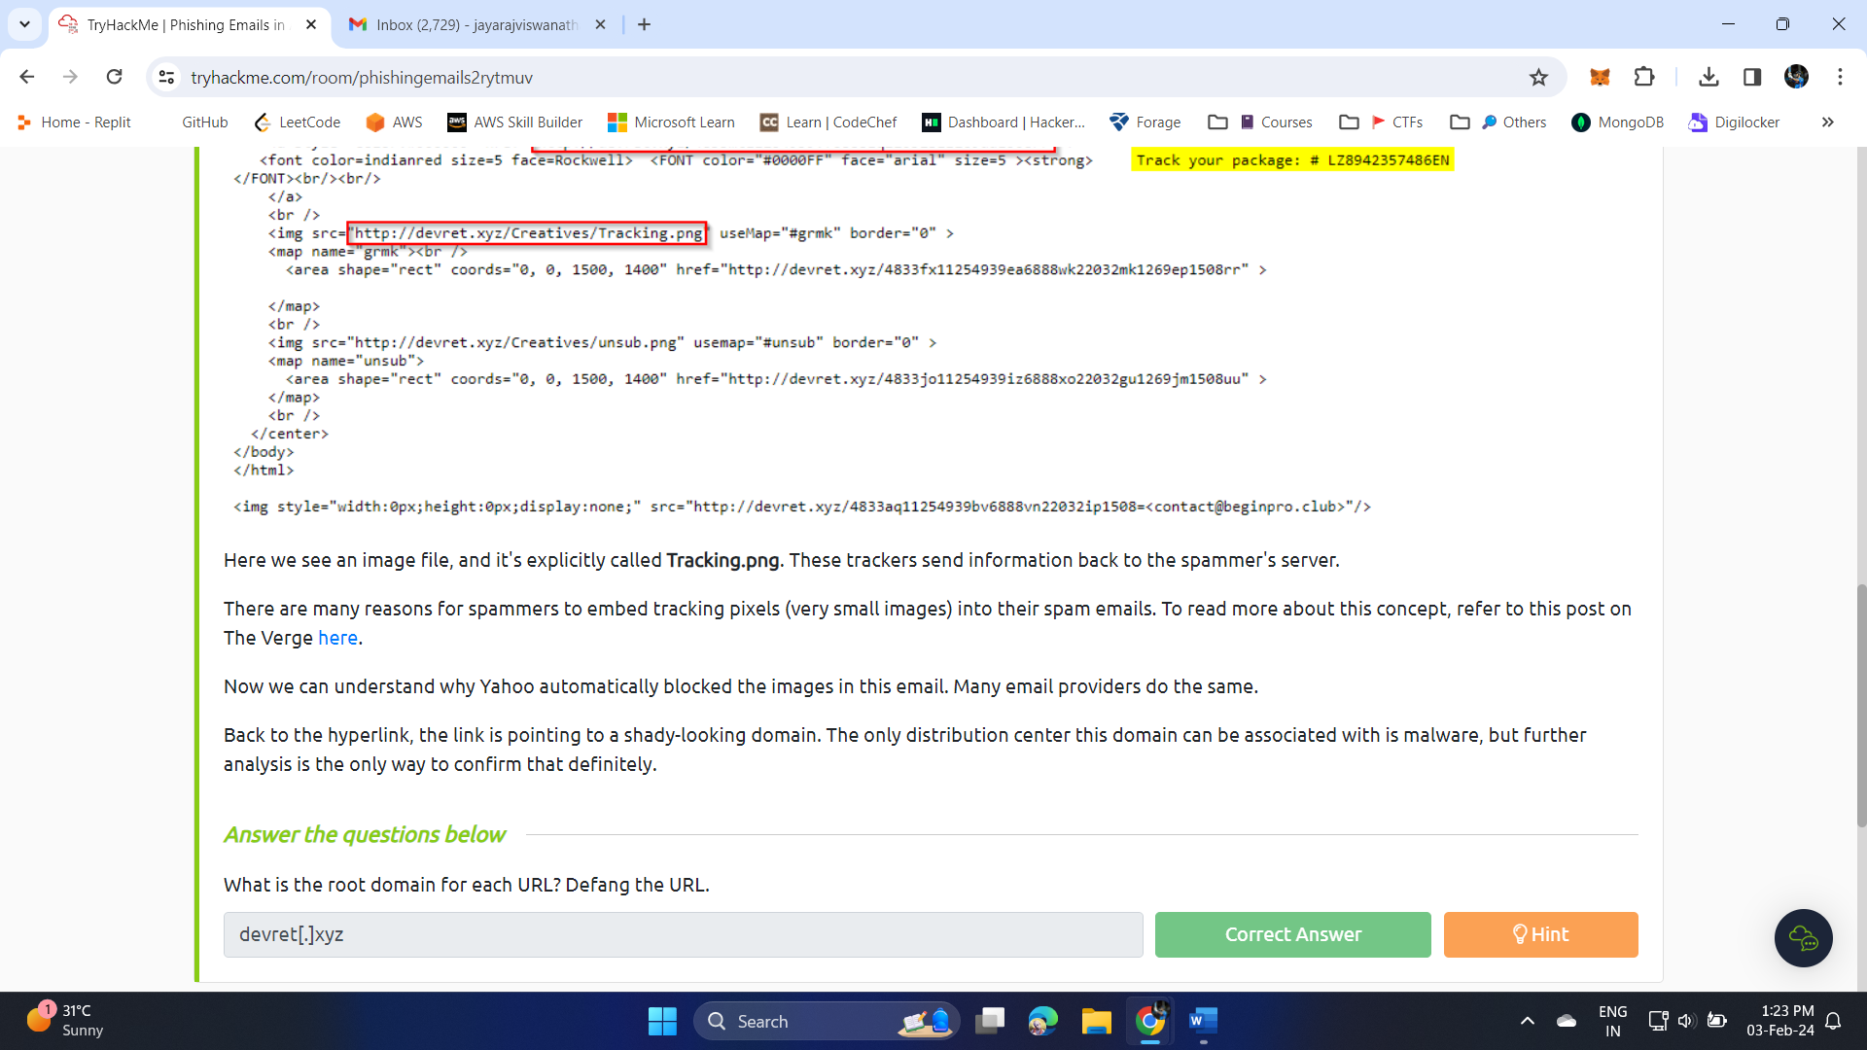

1. This email sample used the names of a few major companies, their products, and logos such as OneDrive and Adobe. What other company name was used in this phishing email? – Citrix

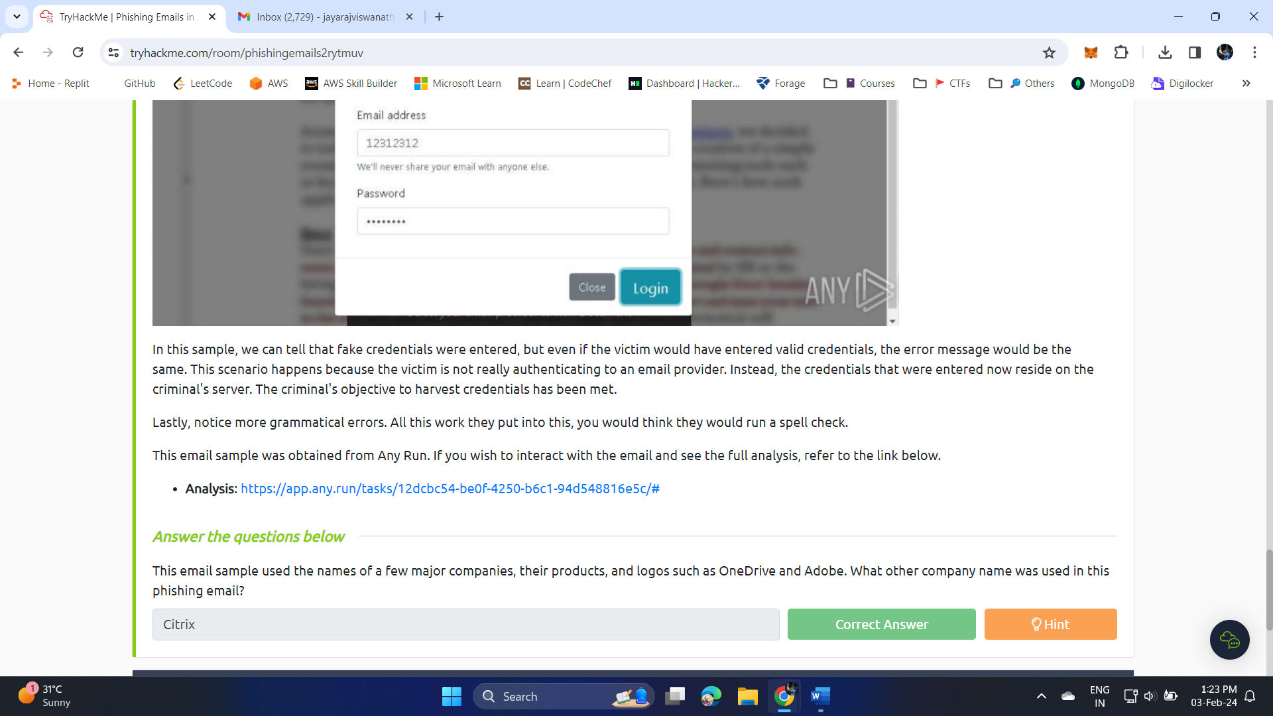

1. What should users do if they receive a suspicious email or text message claiming to be from Netflix? - forward the message to [phishing@netflix.com](mailto:phishing@netflix.com%20)

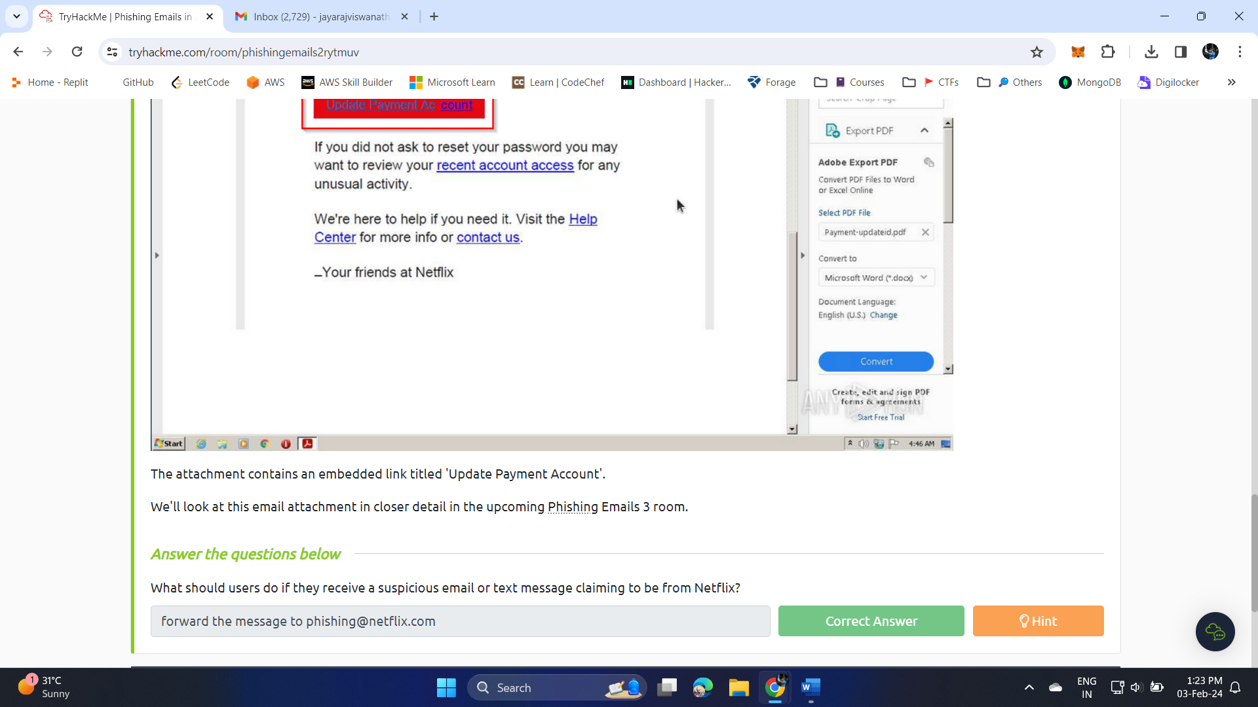

1. What does BCC mean? - Blind Carbon Copy
2. What technique was used to persuade the victim to not ignore the email and act swiftly? - Urgency

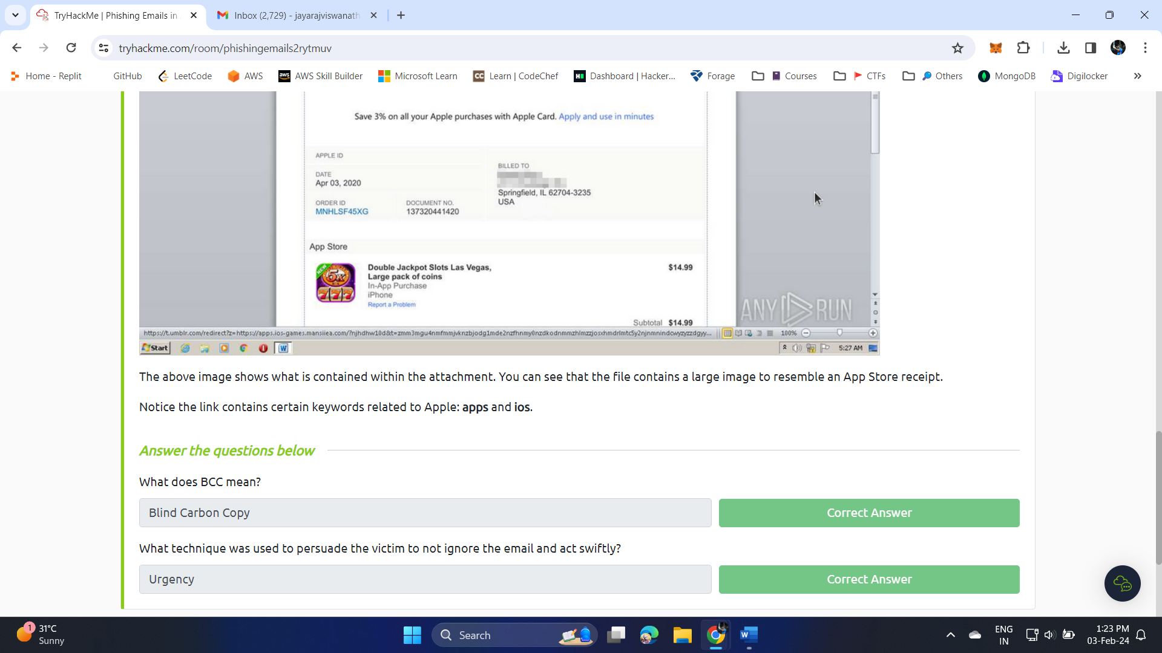

1. What is the name of the executable that the Excel attachment attempts to run? - regasms.exe

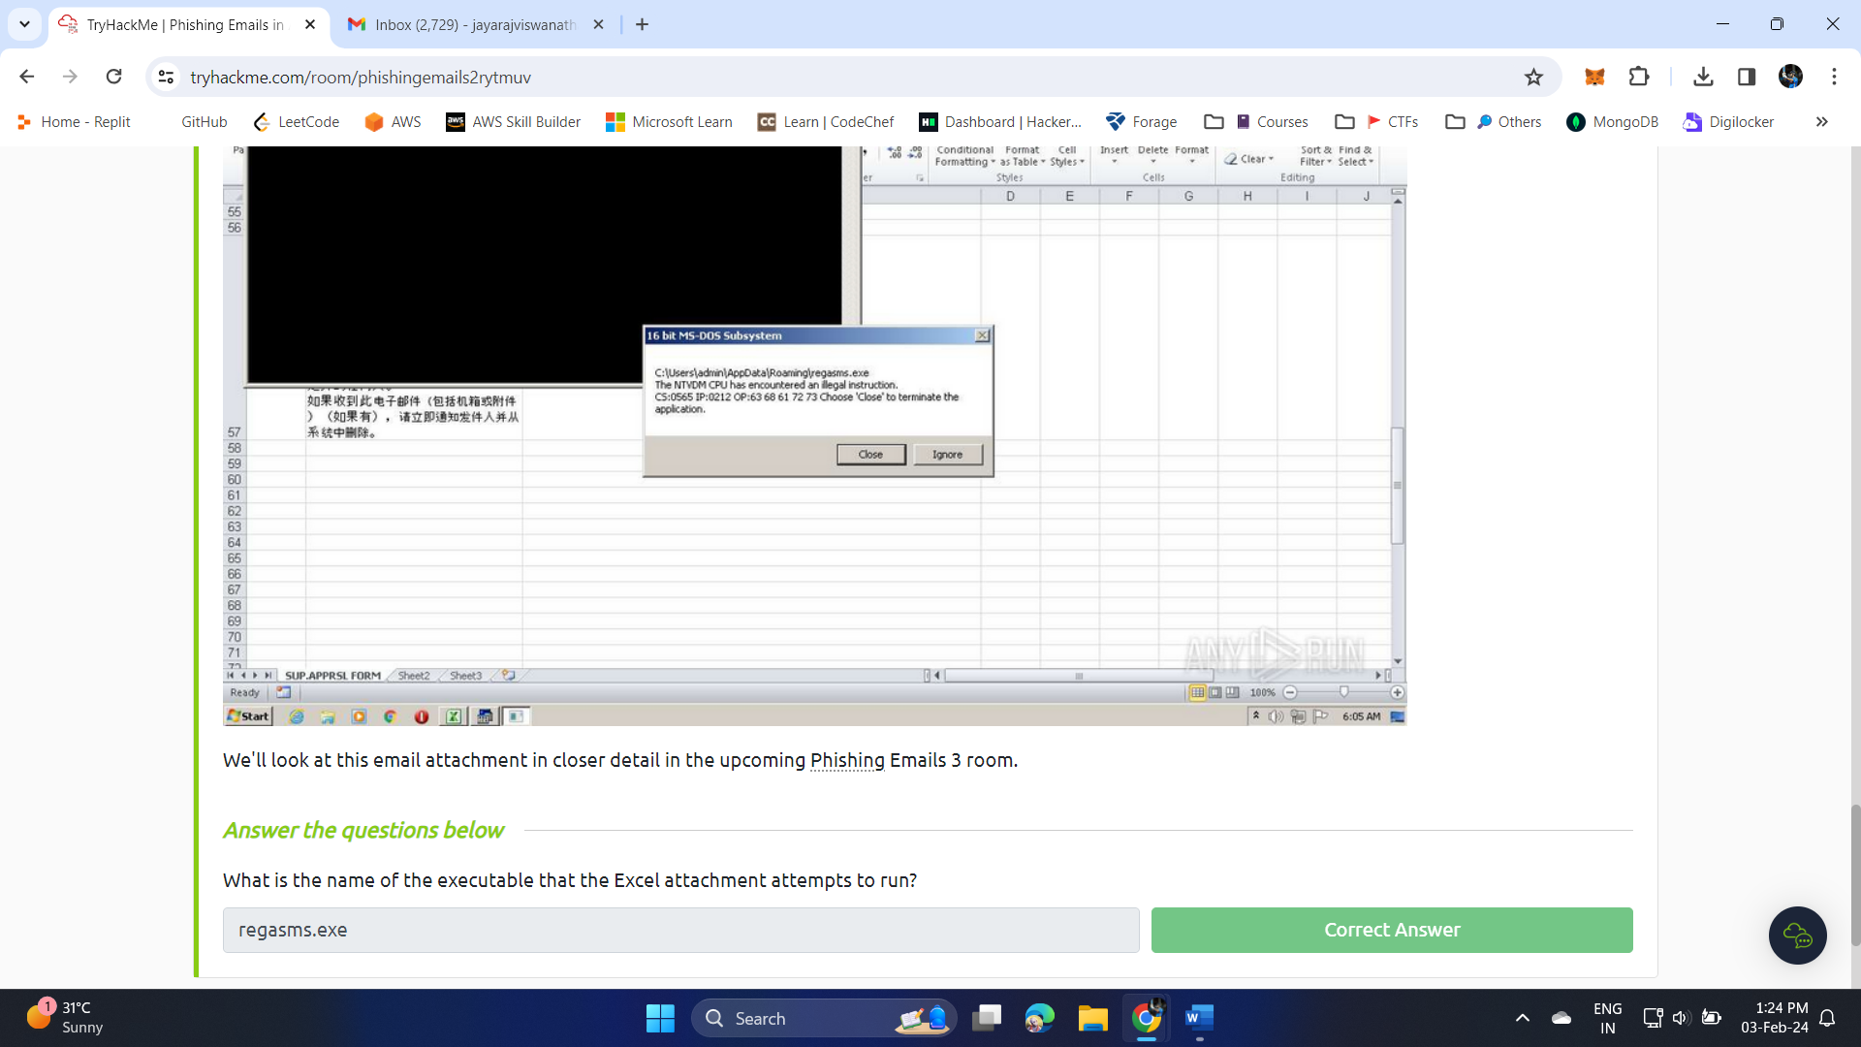

**EX-6: Browser Forensics**

**Aim:**

1. Locate the browser data

Path in my local system - C:\Users\HP\AppData\Local\Google\Chrome\User Data\Default

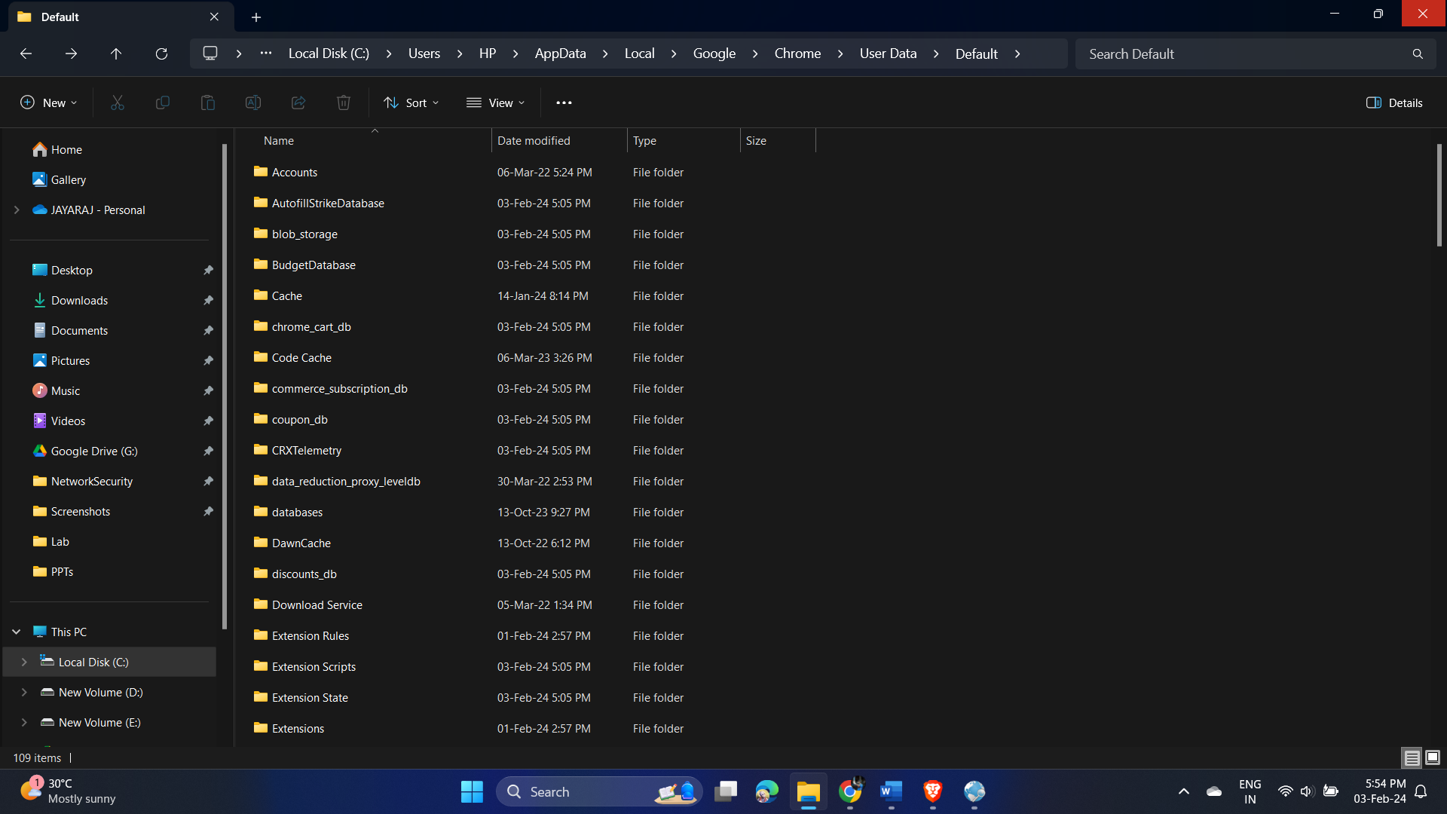

1. Load the folder in “Browser History View” Tool

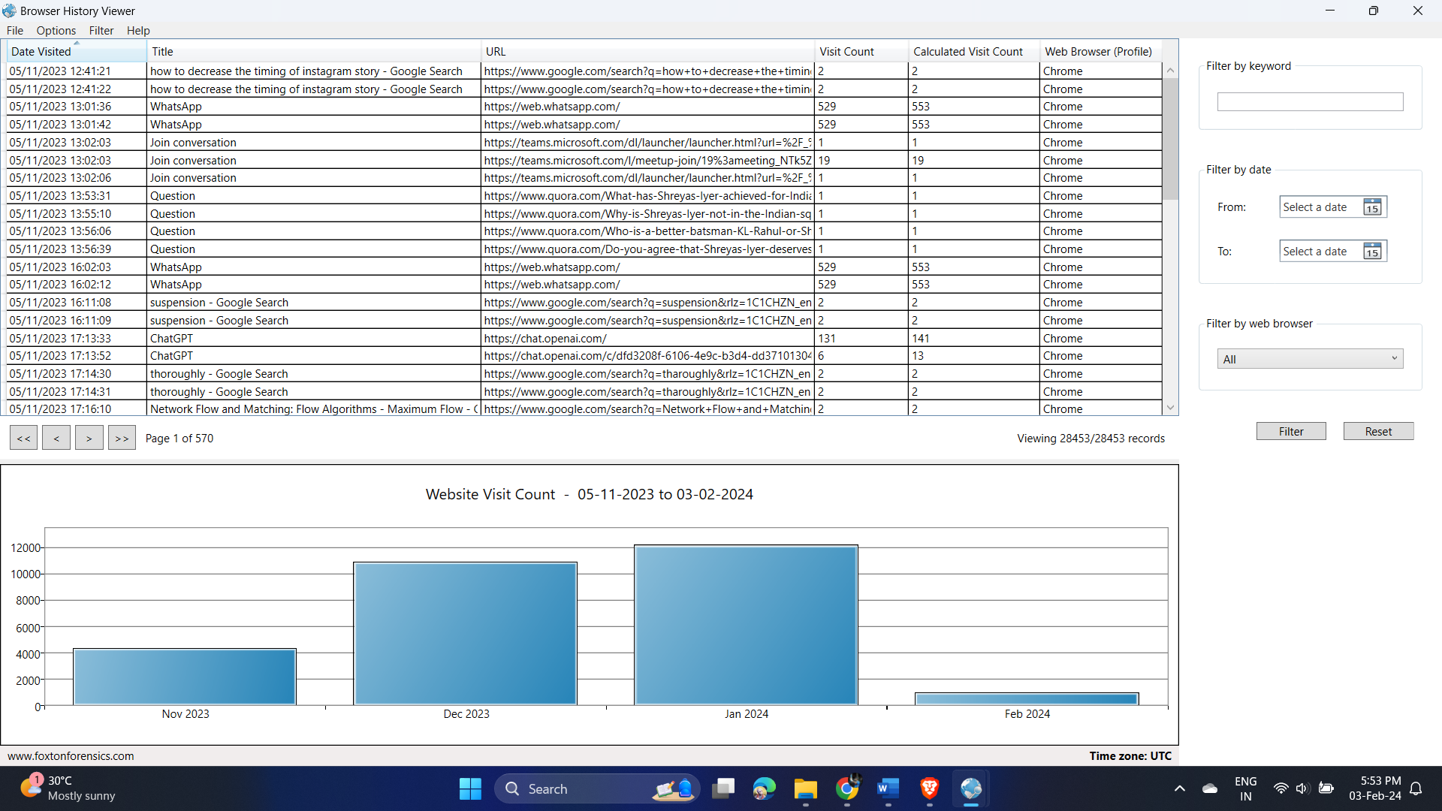

1. Using the filter option – “aws”

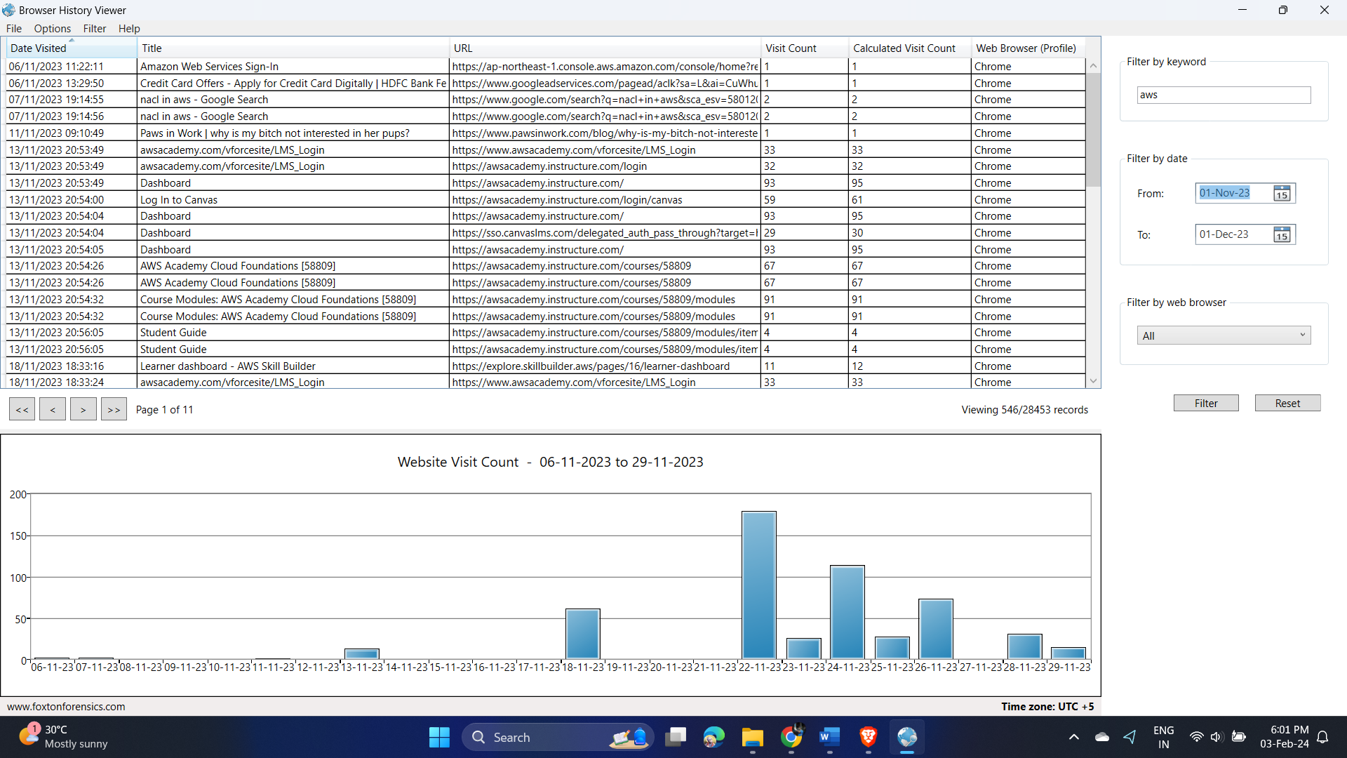

1. Filter by date

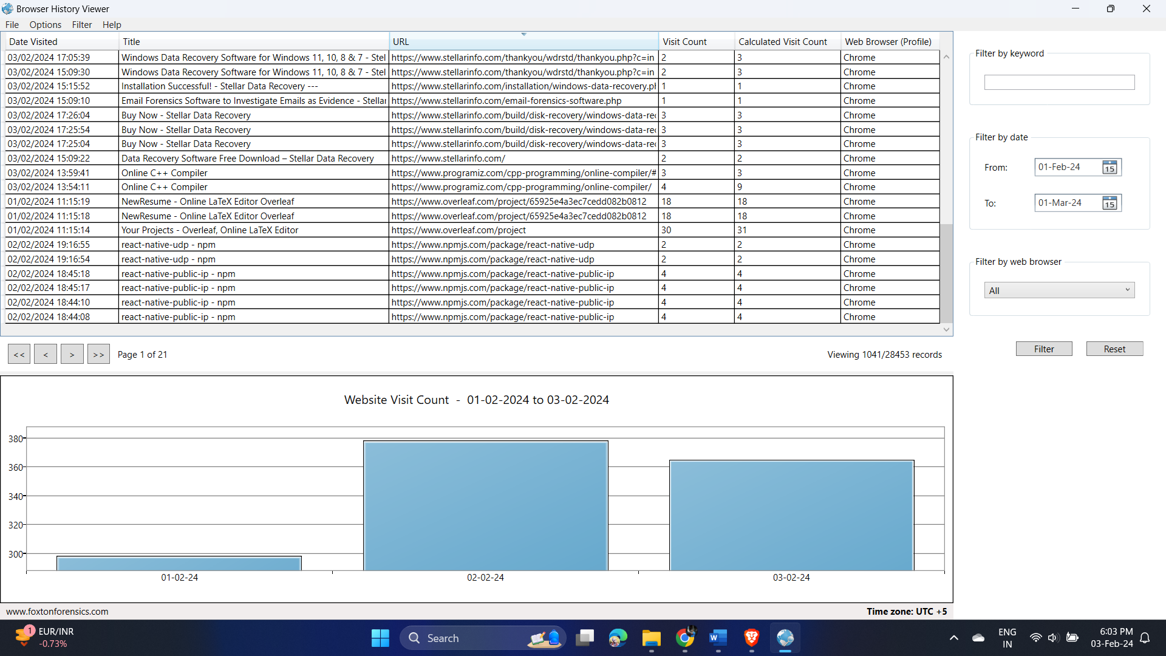

**EX-7: Network Forensics**

**Aim:**

Identify the malware & possible network traffic sensors

**Output:**

* **Scenario1.pcapng**

1. Open the scenario1.pcapng file in wireshark and make the necessary configurations.

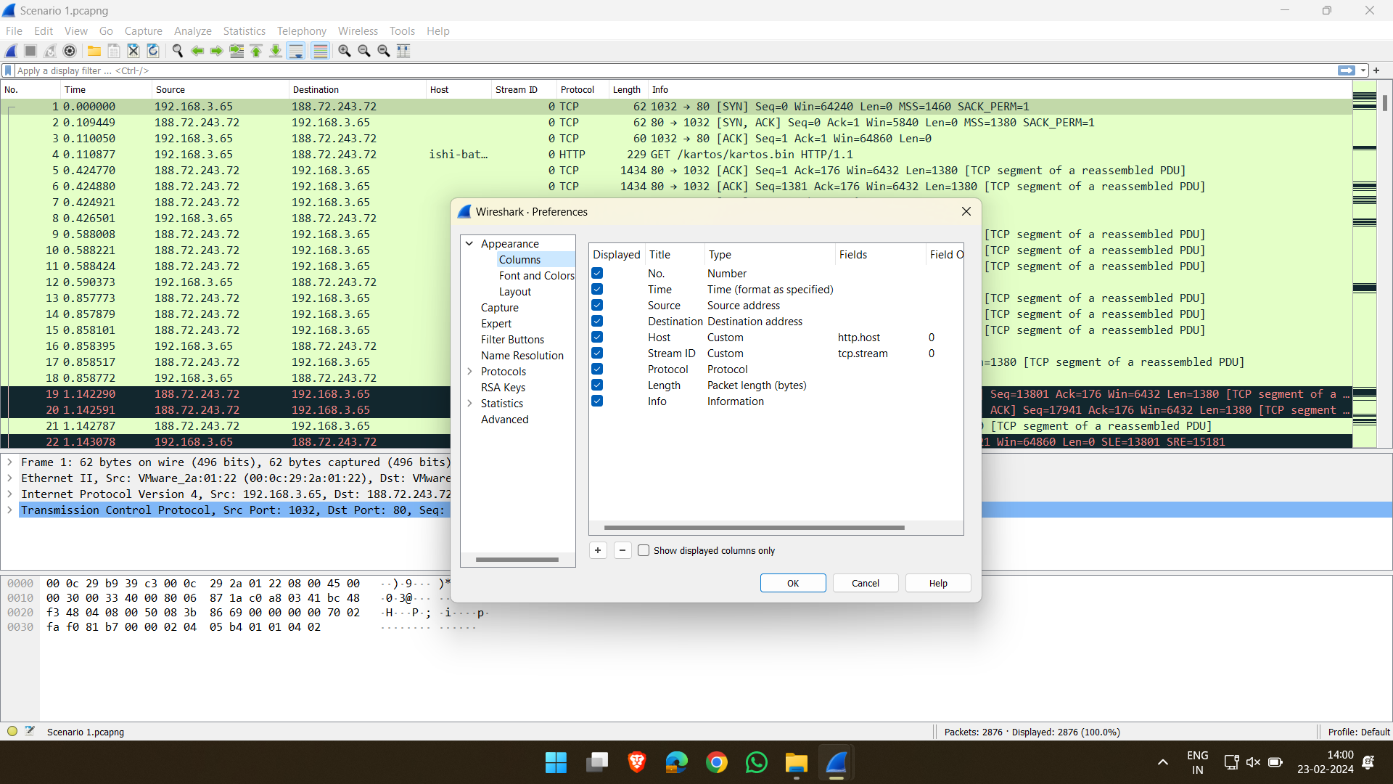

1. Use the filter option with the cmd: ipaddr == 12.183.1.55

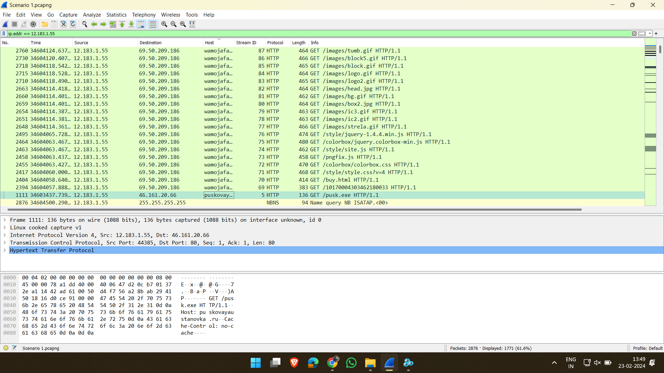

1. Right click and follow that TCP stream. Notice that it starts with “MZ”.

MZ 🡪 signature of exe file

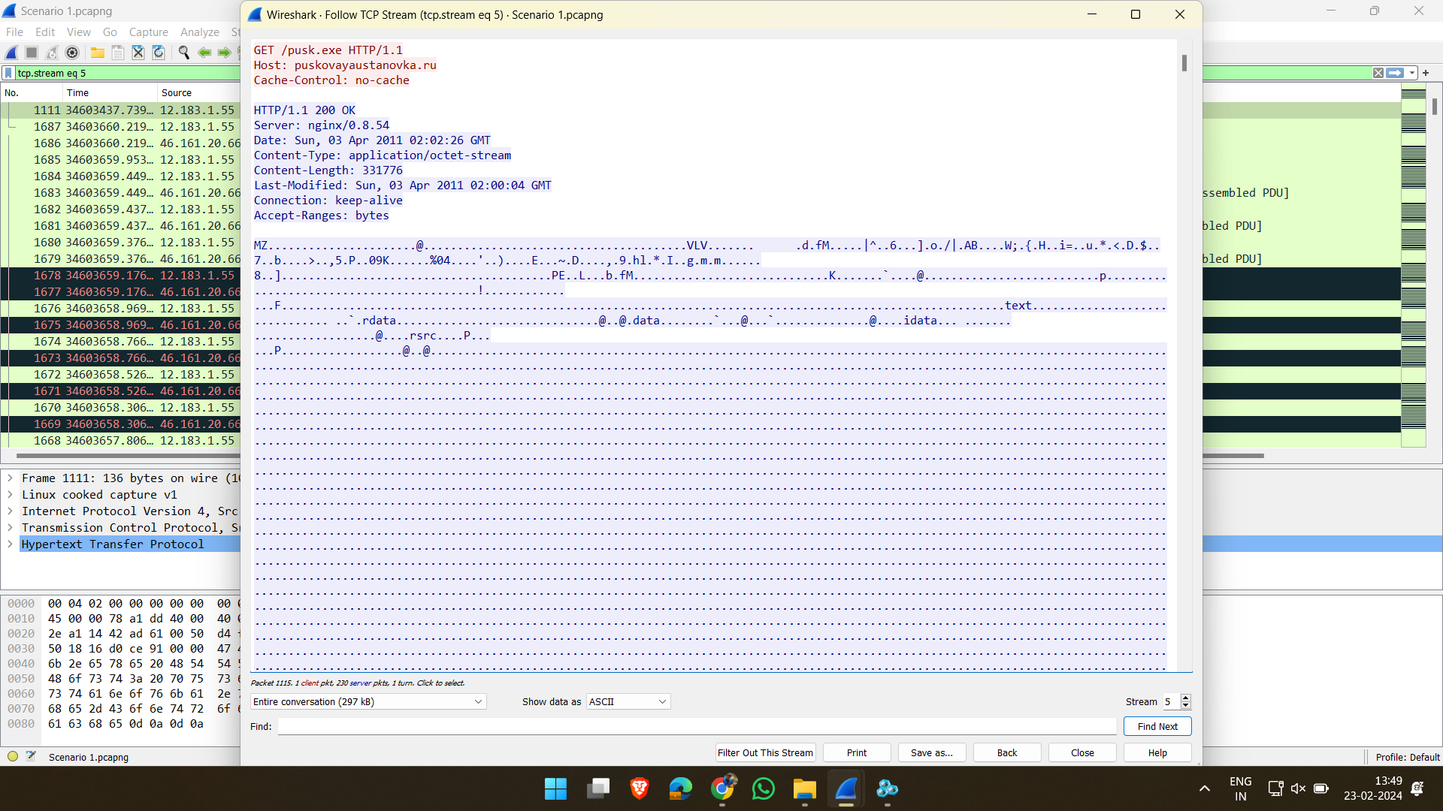

1. Now save the file in HEX format

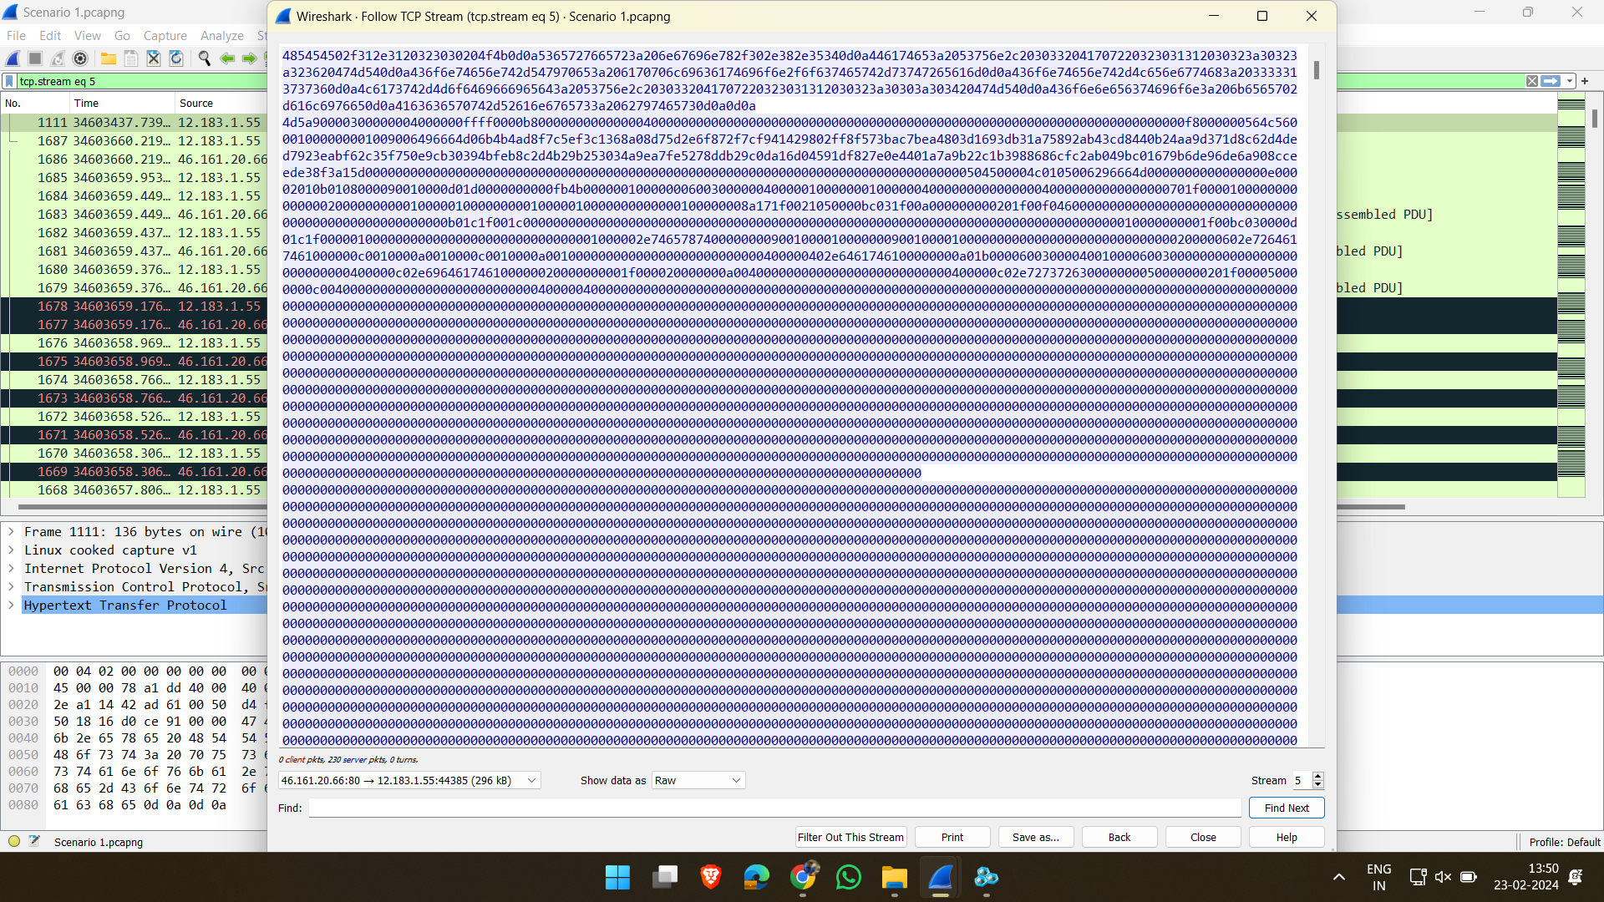

1. Filter using the cmd: ipaddr == 12.183.1.55 && !tcp.stream == 5

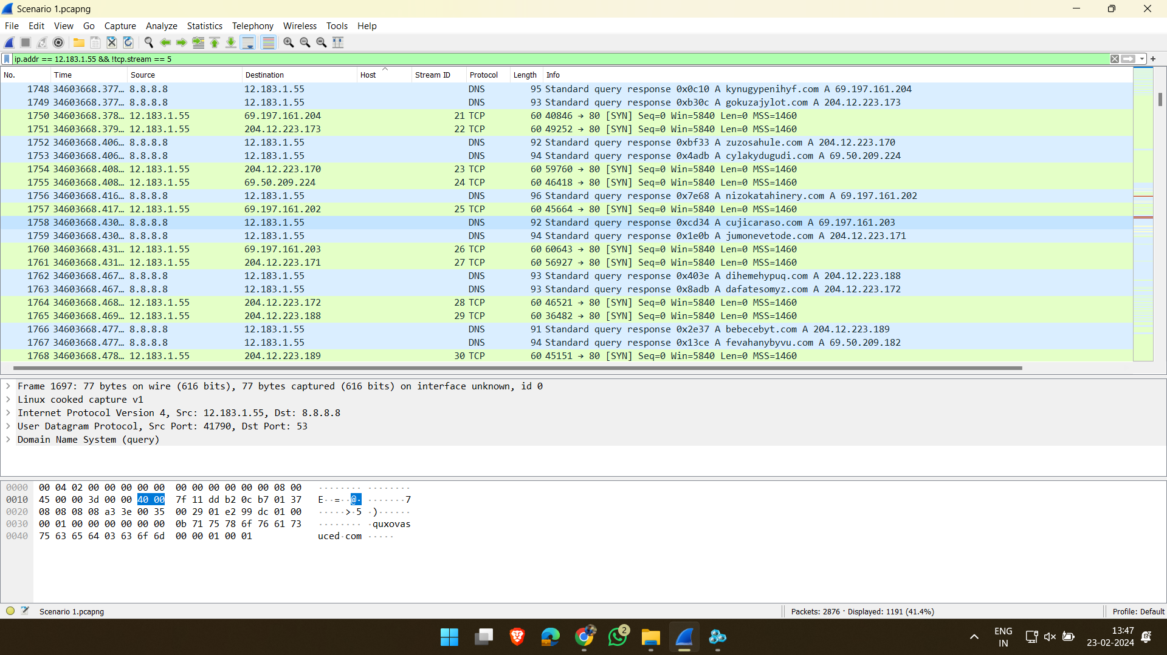

1. Using Hex editor remove the headers before the word “MZ” and save the file. Upload the file in virustotal to check for malware signatures.

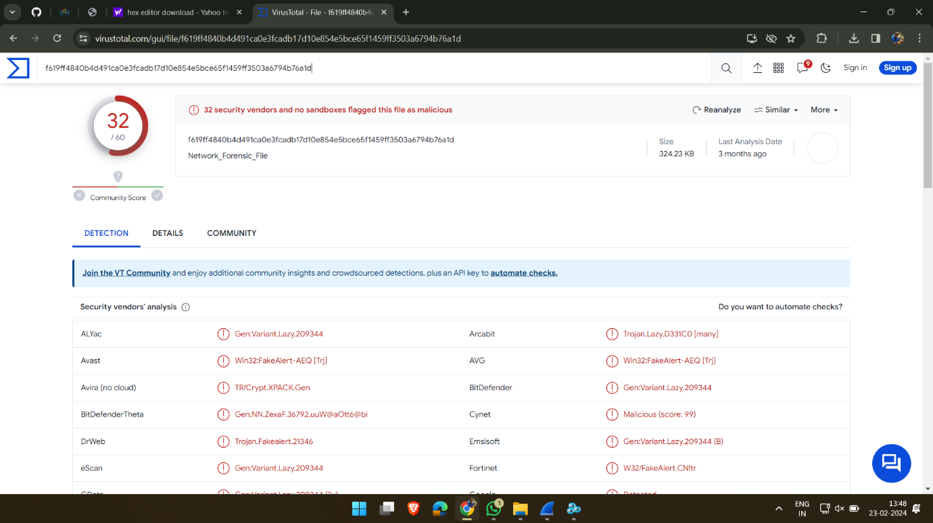

* **Scenario2.pcap**

1. Open scenario2.pcap file in wireshark.

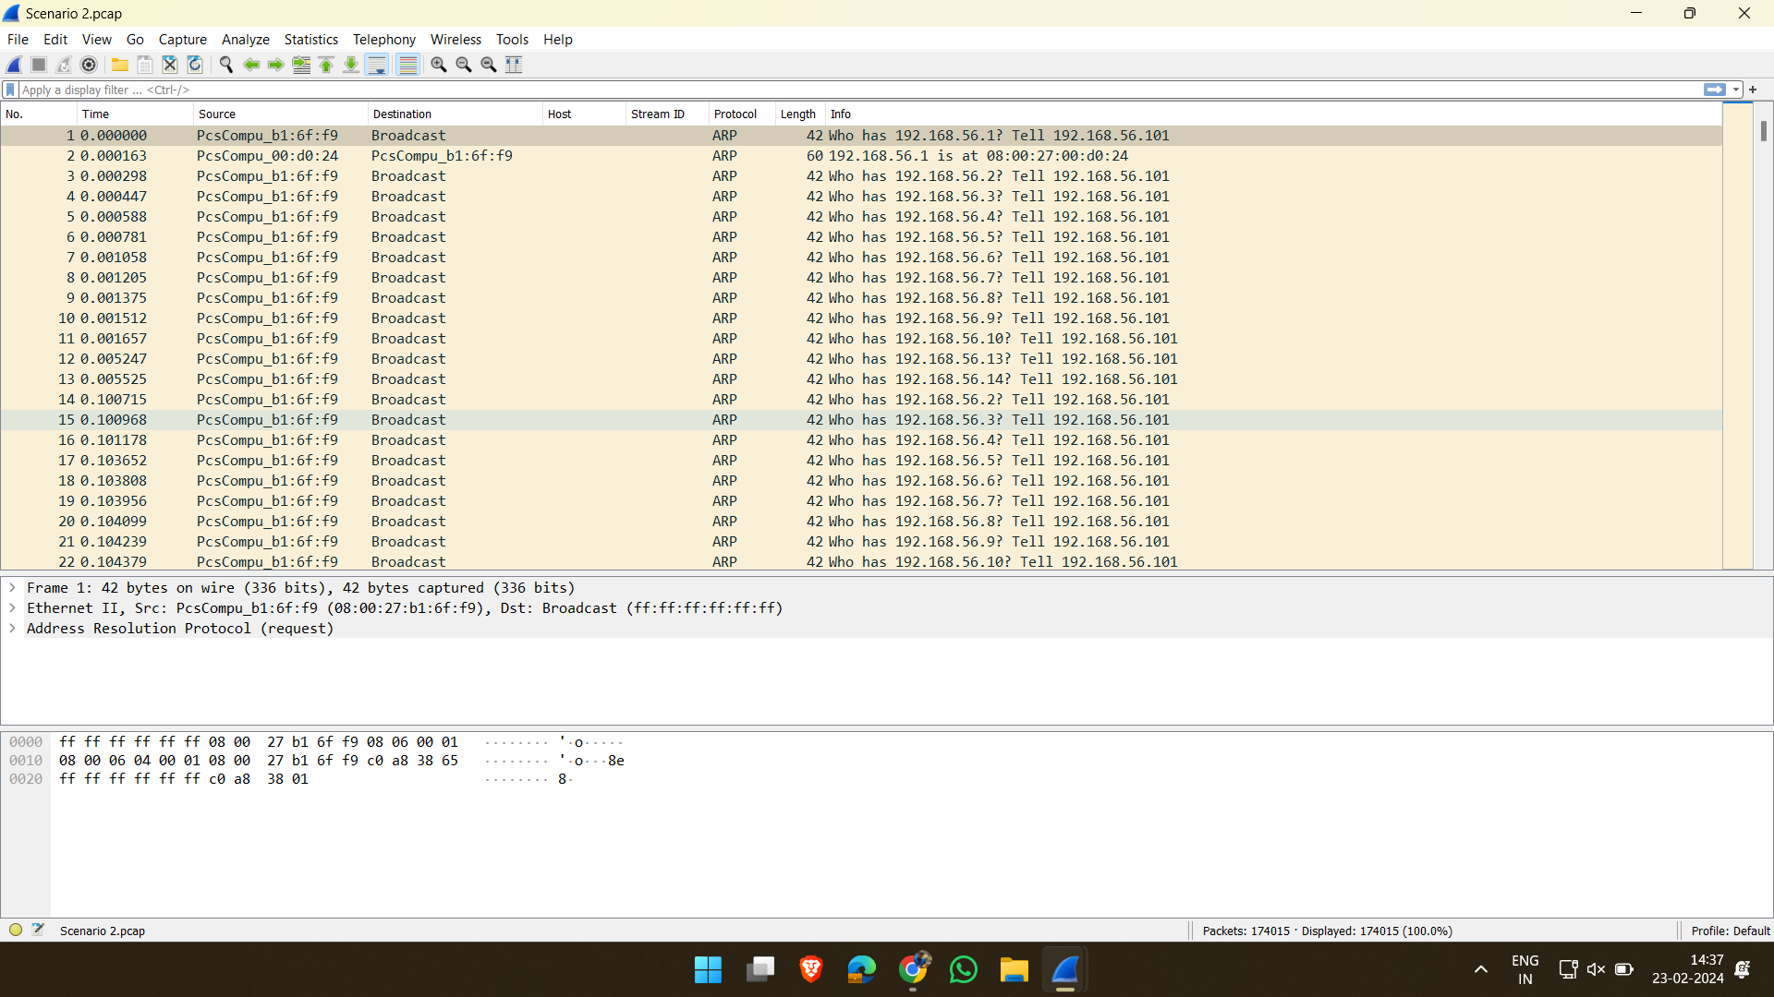

1. Look for communications and notice that only 2 parties were communicating.

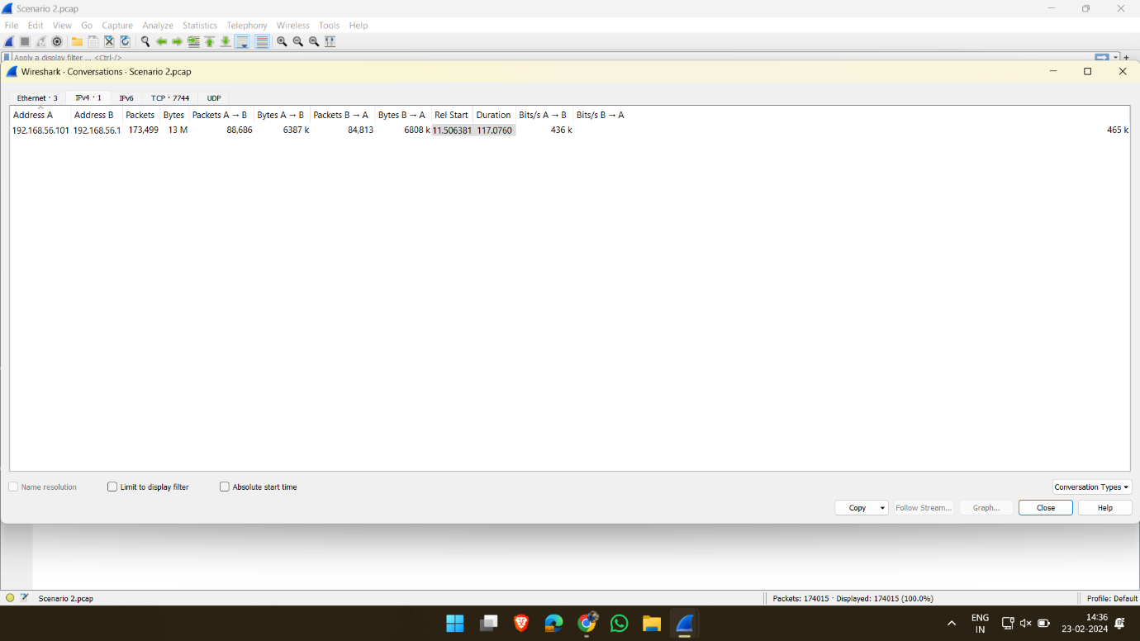

1. Use the filter option cmd: tcp.flags == 0x012. Notice that incorrect login attempts have a ftp response of 530 and correct response has a code of 230

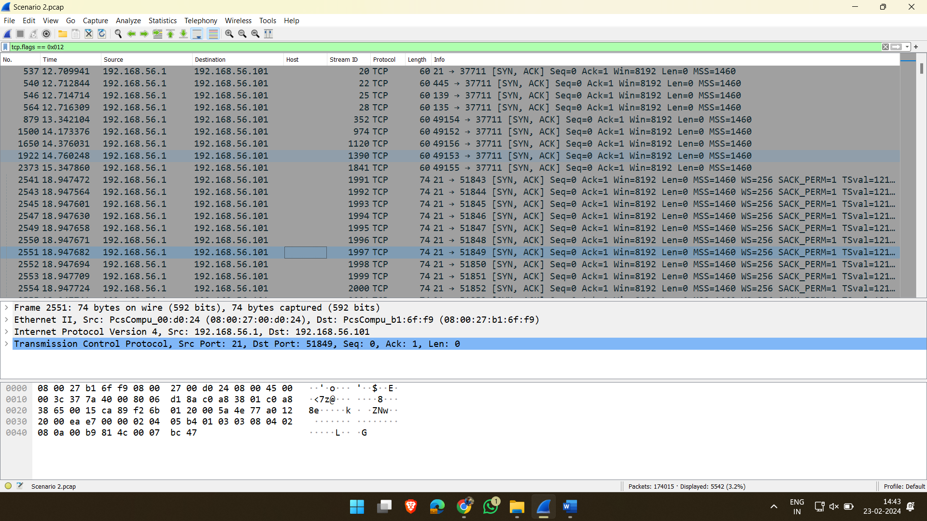

1. Use the filter cmd: [ftp.response.code](ftp://ftp.response.code) == 230. Now we can access the ftp packets with correct credentials which starts from seq no. 3640 and ack no. 7356

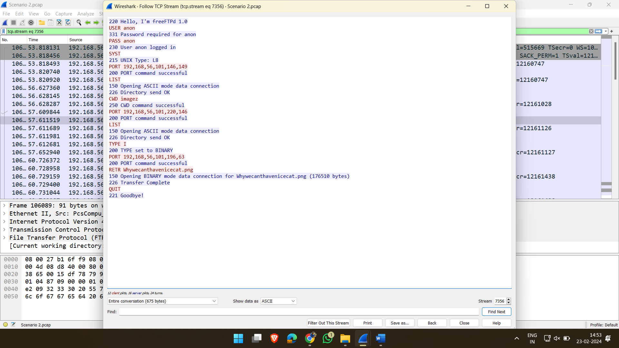

5) Search the packets for the png image “Whywecanthavenicecat.png”. Convert the file as raw and save it with .png extension.

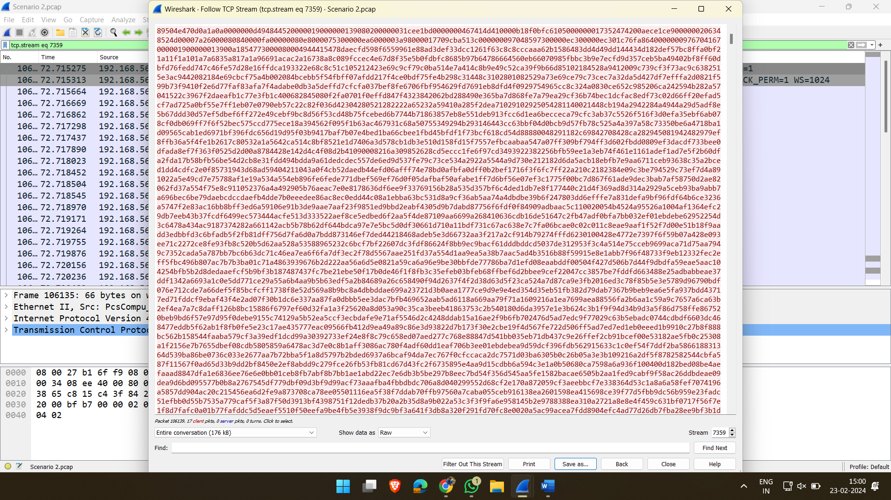

6) This is the required file.



**EX-8: Extracting Slack Space using WinHex**

**Aim:**

Identify the malware & possible network traffic sensors

**Output:**

**EX-9: Steganography Image**

**Aim:**

To perform image steganography

**Output:**



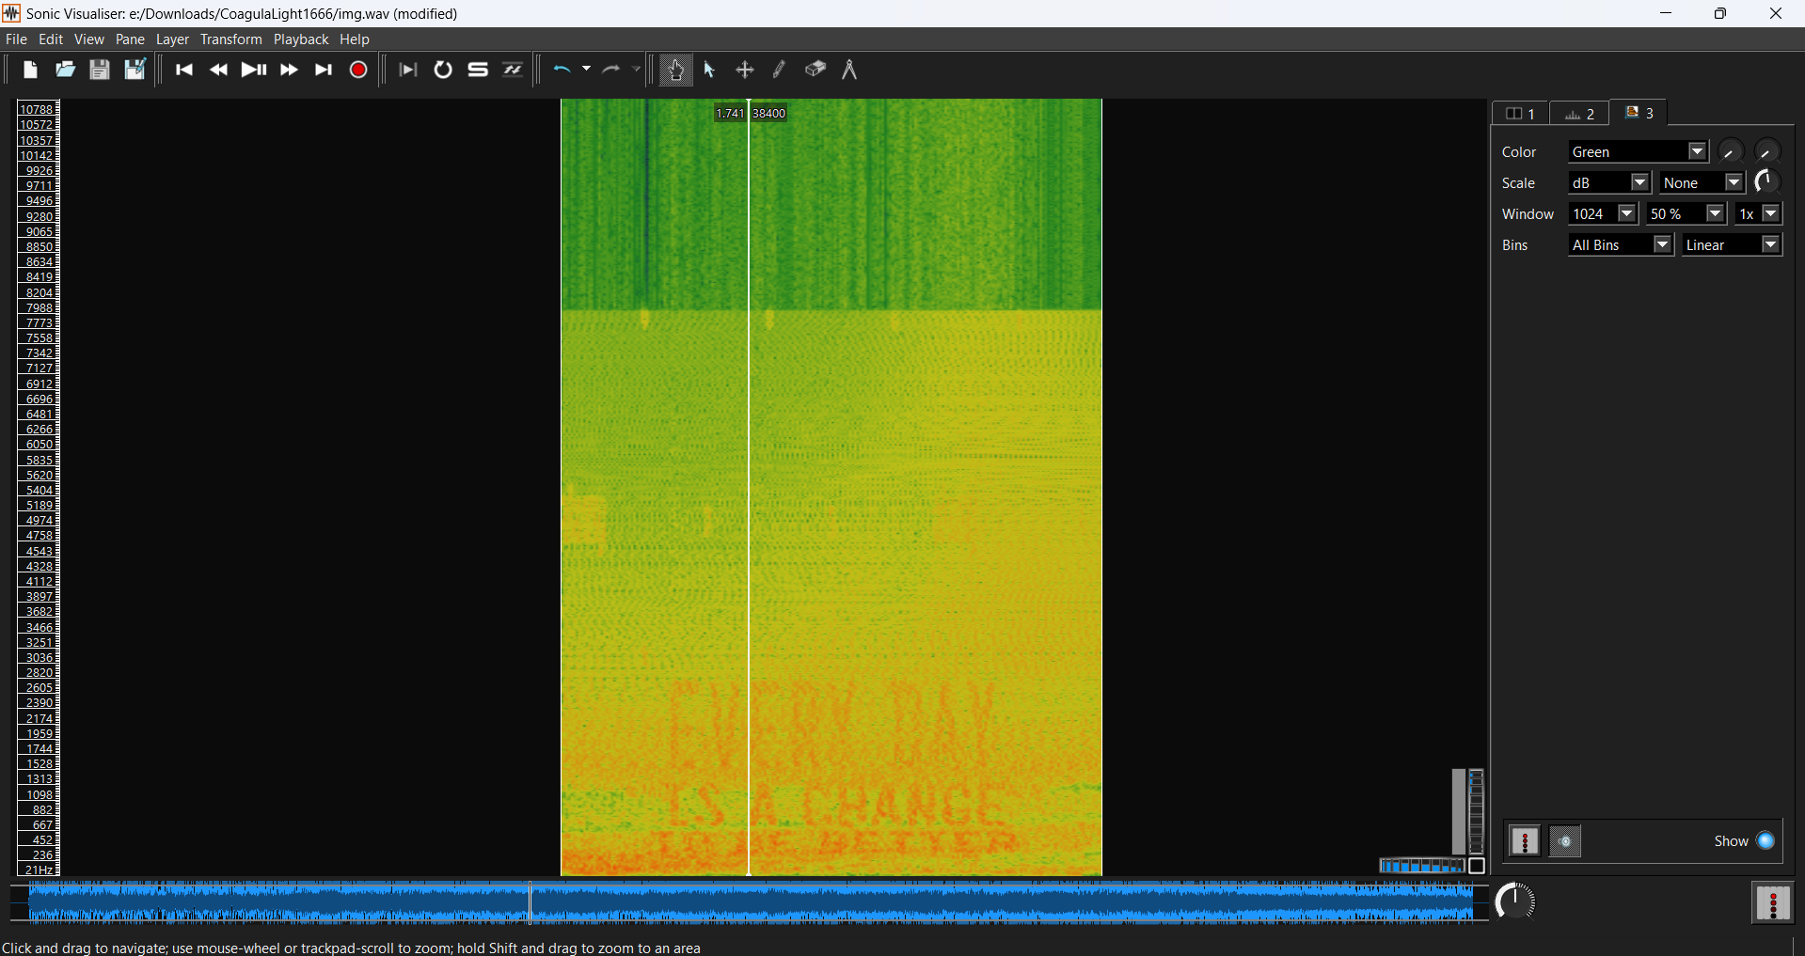



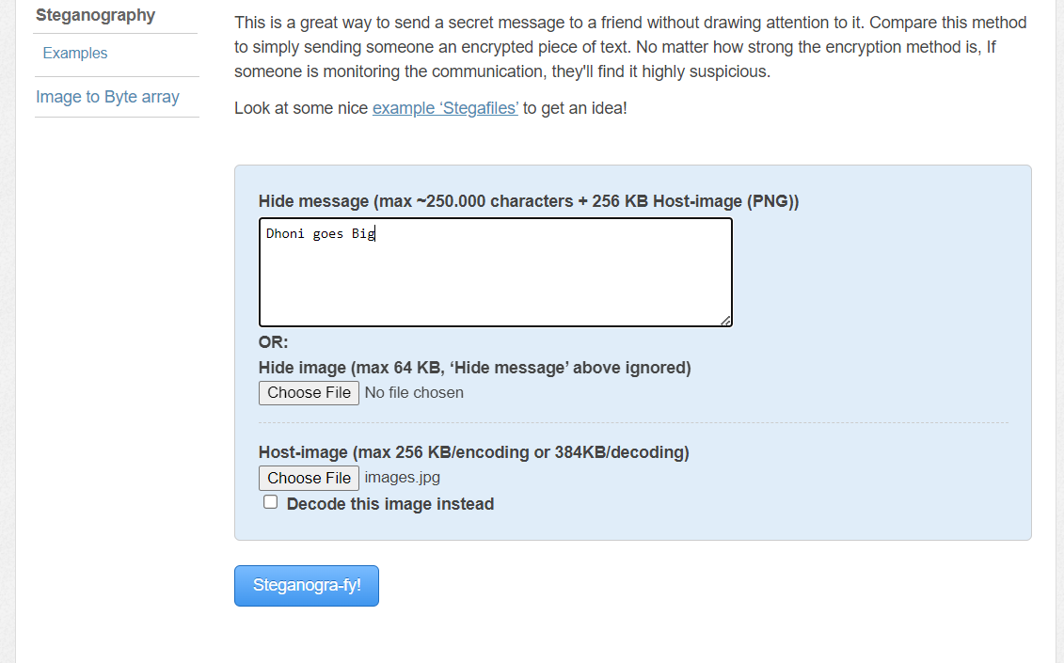



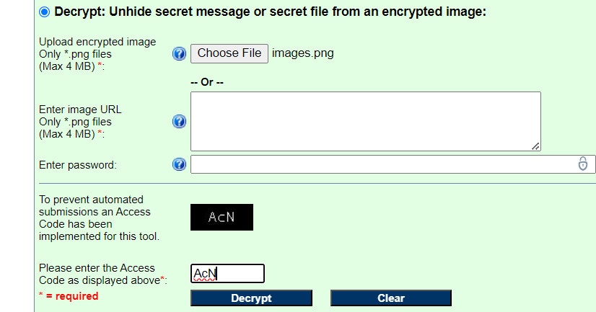

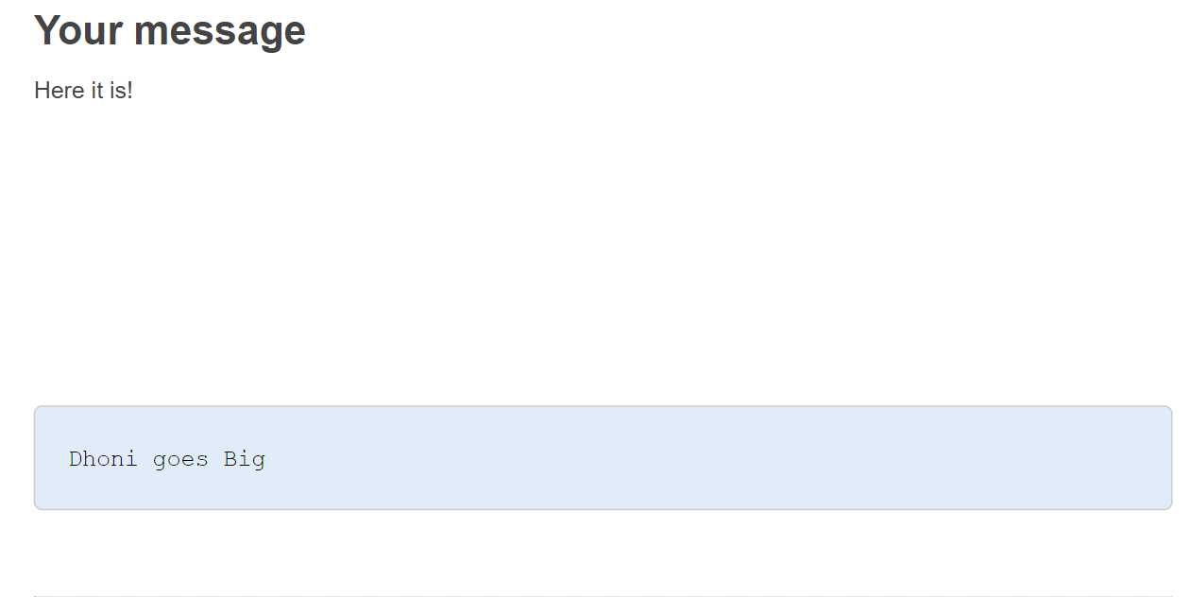

**EX-10: Write Blocker**

**Aim:**

To perform image steganography

**Output:**

**EX-12: Windows Registry**

**Aim:**

To perform image steganography

**Output:**

**EX-13: Validating and gathering evidence using DOS Commands**

**Aim:**

To perform image steganography

**Output:**

